



**Travel Management System**

**Second Year Group**

**Project 2020**

**Proposal**

# Details of Project Supervisor, Co-supervisor

Proposed Project Supervisor (Academic Staff of UCSC):

Name of the supervisor : Ms. Kulani Sumanasekara

Signature of the supervisor : Kulani Sumanasekara

Date : 25.05.2020

Proposed Project Co-Supervisor (Assigned by Course Coordinator):

Name of the co-supervisor : Ms. Gayani Rupasinghe

Signature of the co-supervisor: Gayani Rupasinghe

Date : 25.05.2020

**Degree Program: Information Systems**

**Group Number: 07**

Group members:

* Asini Pathmila Silva (18020798)
* Ruwanthi Hemachandra (18020291)
* Hansaka Sandaruwan (18020704)
* Sachini Maleesha (18020356)

# Table of the content

Details of Project Supervisor, Co-supervisor 1

Table of the content 2

List of the figures 4

List of tables 6

1. Problem Statement 7

2. Project Goals 11

3. Project Scope 11

3.1 Identify the project scope and clear boundaries 11

4. Project Objectives 12

5. Feasibility Study 13

5.1 Technical Feasibility 13

5.2 Economic feasibility 14

5.3 Legal and Ethical feasibility 14

5.4 Schedule feasibility 14

5.5 Operational feasibility 15

6. Deliverables of the project. 16

7. Methodology 16

7.1 Development Model 16

7.2 Reasons to select this development model 17

8. Project constraints and assumptions identification 18

8.1 Project constraints 18

8.1.1 Cost 18

8.1.2 Scope 18

8.1.3 Quality 18

8.1.4 Customer Satisfaction 18

8.1.5 Risk 18

8.1.6 Resources 18

8.1.7 Time 18

8.2 Assumptions 19

9. Functional Requirement Identification 20

9.1 Component diagram 22

9.2 Use case diagram 23

9.2.1 Actor wise use cases 24

9.3 Use case Descriptions 27

9.3.1 Use case descriptions for Admin’s functionalities. 27

9.3.2 Use case descriptions for User’s functionalities. 32

9.3.3 Use case descriptions for Guide’s functionalities. 36

9.3.4 Use case descriptions for the hotel's functionalities. 38

9.3.5 Use case descriptions for vehicle’s functionalities. 40

9.4 Activity Diagrams 42

9.4.1 Activity diagrams for User 42

9.4.2 Activity diagrams for Admin 54

9.4.3 Activity diagrams for Hotel 69

9.4.4 Activity diagrams for Guide 74

9.4.5 Activity diagrams for Vehicle 79

10. Non-Functional Requirements 84

10.1 Identification of Quality Attributes 84

10.2 Suggestion to achieve Quality Attributes 84

11. Technologies to be used. 86

12. Work Breakdown Structure 87

13. Project Timeline 88

13.1 Block Timeline 88

13.2 Project Milestone Timeline 88

14. Gantt Chart 89

15. Declaration 92

16. References 93

# List of the figures

|  |  |
| --- | --- |
| *Figure 01: Survey Results* | 08 |
| *Figure 02: Schedule feasibility graph* | 15 |
| *Figure 03: Waterfall Model* | 16 |
| *Figure 04: Component Diagram* | 22 |
| *Figure 05: Use case Diagram* | 23 |
| *Figure 06: Use case Diagram for the user* | 24 |
| *Figure 07: Use case Diagram for the hotel* | 25 |
| *Figure 08: Use case Diagram for the guide* | 25 |
| *Figure 09: Use case Diagram for the vehicle* | 26 |
| *Figure 10: Use case Diagram for the admin* | 26 |
| *Figure 11: User login to the system* | 42 |
| *Figure 12: User creates an account* | 43 |
| *Figure 13: User adds comments* | 44 |
| *Figure 14: User books travel package* | 45 |
| *Figure 15: User cancels the booking* | 46 |
| *Figure 16: User deletes the account* | 47 |
| *Figure 17: User does the payment* | 48 |
| *Figure 18: User search* | 49 |
| *Figure 19: User updates the account* | 50 |
| *Figure 20: User view [not registered user]* | 51 |
| *Figure 21: User view [registered user]* | 52 |
| *Figure 22: User sends message* | 53 |
| *Figure 23: Admin login to the system* | 54 |
| *Figure 24: Admin views accounts* | 55 |
| *Figure 25: Admin views bookings* | 56 |
| *Figure 26: Admin views reports* | 57 |
| *Figure 27: Admin adds travel package* | 58 |
| *Figure 28: Admin adds category* | 59 |
| *Figure 29: Admin adds subcategory* | 60 |
| *Figure 30: Admin adds destinations* | 61 |
| *Figure 31: Admin checks availability* | 62 |
| *Figure 32: Admin deletes category* | 63 |
| *Figure 33: Admin deletes subcategory* | 64 |
| *Figure 34: Admin deletes travel package* | 65 |
| *Figure 35: Admin updates category* | 66 |
| *Figure 36: Admin updates subcategory* | 67 |
| *Figure 37: Admin updates travel package* | 68 |
| *Figure 38: Hotel login to the system* | 69 |
| *Figure 39: Hotel creates an account* | 70 |
| *Figure 40: Hotel updates the account* | 71 |
| *Figure 41: Hotel deletes the account* | 72 |
| *Figure 42: Hotel changes the availability* | 73 |
| *Figure 43: Guide login to the system* | 74 |
| *Figure 44: Guide creates an account* | 75 |
| *Figure 45: Guide updates the account* | 76 |
| *Figure 46: Guide deletes the account* | 77 |
| *Figure 47: Guide changes the availability* | 78 |
| *Figure 48: Vehicle login to the system* | 79 |
| *Figure 49: Vehicle creates an account* | 80 |
| *Figure 50: Vehicle updates the account* | 81 |
| *Figure 51: Vehicle deletes the account* | 82 |
| *Figure 52: Vehicle changes availability* | 83 |
| *Figure 53: Work Breakdown Structure* | 87 |
| *Figure 54: Block Timeline-1* | 88 |
| *Figure 55: Block Timeline-2* | 88 |
| *Figure 56: Project Milestone Timeline* | 88 |
| *Figure 57: Gantt chart* | 89 |

# List of tables

|  |  |
| --- | --- |
| *Table 01: Use case description for admin logins into the system* | 26 |
| *Table 02: Use case description for admin views accounts’ profiles.* | 26 |
| *Table 03: Use case description for admin views booking list.* | 26 |
| *Table 04: Use case description for admin views the reports.* | 27 |
| *Table 05: Use case description for admin adds a travel package.* | 27 |
| *Table 06: Use case description for admin adds a category* | 27 |
| *Table 07: Use case description for admin adds a subcategory* | 28 |
| *Table 08: Use case description for admin adds a destination* | 28 |
| *Table 09: Use case description for admin checks availability* | 28 |
| *Table 10: Use case description for admin deletes a category* | 29 |
| *Table 11: Use case description for admin deletes a subcategory* | 29 |
| *Table 12: Use case description for admin deletes a travel package* | 29 |
| *Table 13: Use case description for admin updates a category* | 30 |
| *Table 14: Use case description for admin updates a subcategory* | 30 |
| *Table 15: Use case description for admin updates a travel package* | 30 |
| *Table 16: Use case description for user logins into the system* | 31 |
| *Table 17: Use case description for user creates an account* | 31 |
| *Table 18: Use case description for user adds comments* | 31 |
| *Table 19: Use case description for user books travel package* | 32 |
| *Table 20: Use case description for user cancels the booking* | 32 |
| *Table 21: Use case description for user deletes the account* | 32 |
| *Table 22: Use case description for user does the payment* | 33 |
| *Table 23: Use case description for user searches* | 33 |
| *Table 24: Use case description for user updates the account* | 33 |
| *Table 25: Use case description for user [not registered user] views* | 34 |
| *Table 26: Use case description for user [registered user] views* | 34 |
| *Table 27: Use case description for user sends a message* | 34 |
| *Table 28: Use case description for guide login into the system* | 35 |
| *Table 29: Use case description for guide creates and account* | 35 |
| *Table 30: Use case description for guide updates the profile* | 35 |
| *Table 31: Use case description for guide deletes the account* | 36 |
| *Table 32: Use case description for guide changes availability* | 36 |
| *Table 33: Use case description for hotel logins into the system* | 37 |
| *Table 34: Use case description for hotel creates an account* | 37 |
| *Table 35: Use case description for hotel updates the account* | 37 |
| *Table 36: Use case description for hotel deletes the account* | 38 |
| *Table 37: Use case description for hotel changes availability* | 38 |
| *Table 38: Use case description for vehicle logins into the system* | 39 |
| *Table 39: Use case description for vehicle creates an account* | 39 |
| *Table 40: Use case description for vehicle updates the account* | 39 |
| *Table 41: Use case description for vehicle deletes the account* | 40 |
| *Table 42: Use case description for vehicle changes availability* | 40 |

# 1. Problem Statement

Nowadays, internet users are increasing. So the purpose of the proposed website is established to internet users to organize their journeys. Our main purpose is to facilitate the best and quality service for organizing journeys for users.

Most people use their way to organize a journey. But it is a time-consuming way to do that. Many people have to face the following issues when they are organizing their journeys.

1. The budget of the travel plan.
2. Finding hotel booking options that are relevant to their plan.
3. Finding a vehicle relevant to the number of travelers.
4. Having less knowledge about the places to visit.

It is not easy to find a hotel according to his budget. Sometimes the conditions of the hotel will not be good. But before someone is booking the hotel, he can’t get an idea about the conditions of that hotel. This will be a practical problem for travel organizing.

Finding a vehicle also creates a problem, because of the budget, condition of the vehicle, and the number of seats, etc. If someone wants to book a vehicle he has to check the conditions of the vehicle. Because of that he has to waste time and money to search for the best vehicle.

Considering the current systems, there are travel packages, but they are not categorized. Most of the current systems targeted most foreign people. The local people want to travel around Sri Lanka, but they can’t think about such packages due to the budget.

From our proposed website, we are providing solutions to these problems. In our website, the user has to choose the travel package selecting the category and the subcategory and just give the personal details and the number of travelers and the number of hotel rooms.

After that, the administrator receives the inquiry and he will find a hotel, vehicle, and guide for the journey. Therefore, it is very easy to go on a journey because the user does not have to worry about the bookings. The administrator of the system will arrange everything.

Another functionality that we provide is the registration of the hotels, guides, and vehicles on our website. From those registered accounts, the administrator will select the hotel, vehicle, and guide according to the package price.

Hotels have to change their availability by entering the available rooms regularly. The guide has to change his availability whether he is free or not and the vehicle owner has to change the availability of the vehicle. From that, they will find customers.

Users can give ratings to the hotel, guide, and vehicle which they had in the journey. So that the quality of the service of the hotel, guide, and the vehicle will be increased. From the feedbacks the proposed system provides easy and quality service to users.

We surveyed to find the problems that people are facing when they are arranging a journey. 89 people responded to our survey. All of them wanted to travel to different places in Sri Lanka.

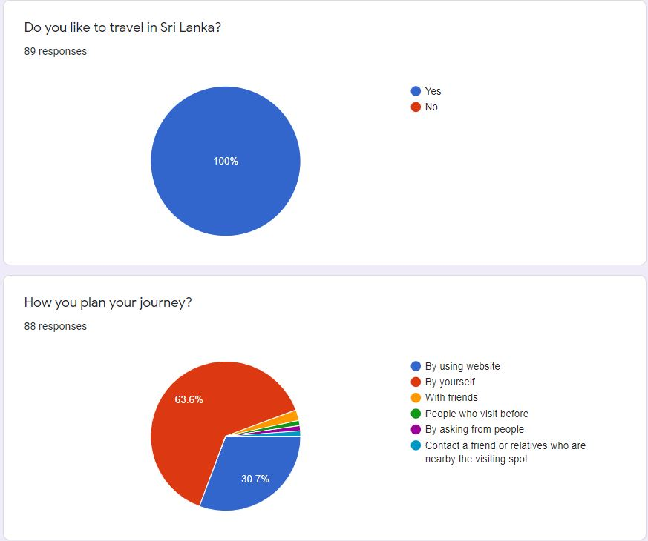

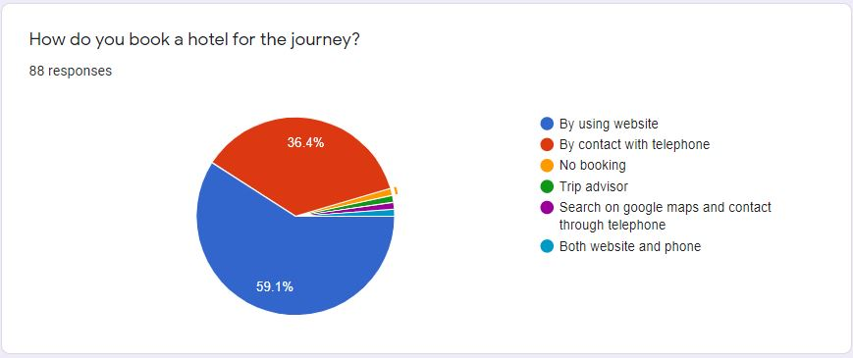

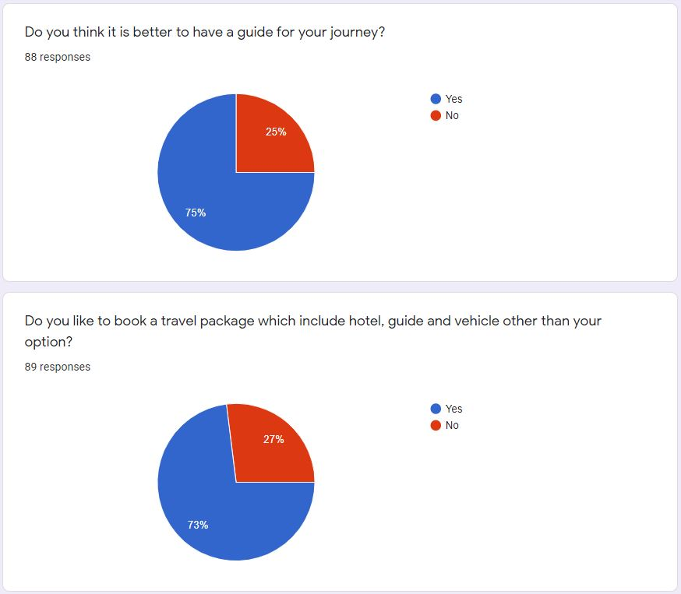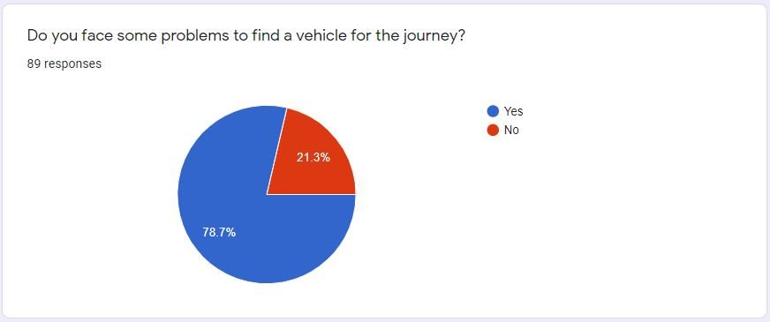

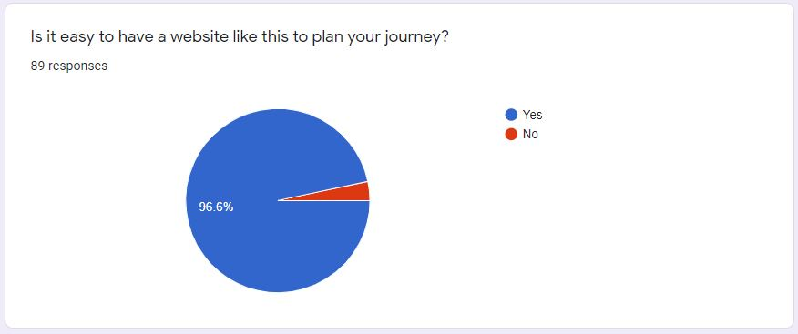

*Figure 01: Survey Results*

* From this little survey, we get an idea about how people are facing problems in booking a vehicle or a hotel. They have to struggle with booking a hotel according to the price and the availability. As well they have to find a vehicle that is suitable for the number of travelers of the journey. They will use different methods to find their needs.
* From the proposed website user can find a better way to manage their journeys. Because the proposed website will fulfill the local peoples’ needs for traveling.

# 2. Project Goals

* Design and implement a comprehensive travel management system within 52 weeks.
* Finish the project with the expected quality of the system.
* Provide a specific, and relevant travel management system.

# 3. Project Scope

## 3.1 Identify the project scope and clear boundaries

* Main actors
  + User ( travelers)
  + Administrator
  + Hotel
  + Guide
  + Vehicle
* Users can view the website but if they want to book a package he has to create an account on the website. After that the user has to select the travel package by selecting the category and the subcategory. Then there will be travel packages.
* From our proposed website, the user has to select the travel package which he likes according to the number of dates, prices, and locations. Users are not allowed for arranging a travel package. That means he has to say ok with the predefined travel packages.
* After the user books a travel package, the user has to pay for the booking. We will use a payment gateway, so that will be an out of boundary activity.
* As well, the user doesn't have an option to select the hotel for accommodation. That will be chosen by the administrator according to the price of the travel package and the number of booked rooms by the user.
* As well the user isn't allowed to choose a vehicle. That is the responsibility of the administrator. He will book the vehicle according to the number of travelers.
* A guide will be chosen by the administrator according to the travel location. There is no option to select a guide by a user.
* Users will be able to cancel the booking before two days of the booking date. If there is no two days gap, the user will be unable to cancel the booking.
* Users will be able to put comments, send messages, search travel packages, and view destinations.
* The administrator has the authority to add, update, delete the travel packages' categories, subcategories, and travel packages.
* The administrator views reports including the list of messages which are sent by users. But the reaction of the admin will be an out of boundary activity.
* User, Hotel, Vehicle, and Guide accounts have the authority to update or delete their accounts.
* Hotel, Vehicle, and Guide accounts have an option to change their availability. Considering the Hotel account, he will update the available number of rooms considering the room’s type. The Vehicle and Guide accounts have the option to change whether they are available or not.
* The administrator organizes the journey by contacting available hotels, guides, and vehicles by checking the availabilities of those accounts. It will be an out of boundary task.

# 4. Project Objectives

* Providing quality service to a user who wants to plan a journey. This will be covered by the professional team and well-designed travel packages.
* Providing an easy way to plan a journey. The user has to select a travel package and book it using the number of travelers and the types of rooms for accommodation. The administrator will find the hotel, vehicle, and guide for the journey.
* Using marketing we are going to promote our website in various market segments. From that organization will get advantages in a competitive market.
* We provide facilities like accommodation, transportation and also there will be a guide according to the user’s needs.
* We are providing facilities to register hotels, vehicles, and guides to the website. From that those registered once will get the opportunity to find customers to their business.
* Establish short-term and long-term profitability by increasing users and other accounts (hotels, guides, and vehicles).

# 5. Feasibility Study

From this feasibility study, we are analyzing whether our software meets the requirements. As well we used this feasibility study to determine whether our software can be implemented using current technology and within a specified budget and schedule. And also we are doing this feasibility study to find whether our software can be integrated with other existing software.

We make this feasibility study covering five areas.

1. Technical Feasibility
2. Economic Feasibility
3. Legal and Ethical Feasibility
4. Operational Feasibility
5. Schedule Feasibility

## 5.1 Technical Feasibility

* Considering our project it is possible with current technologies. When we consider our technical side we are using technologies and tools like, Programming languages (HTML, CSS, JavaScript, PHP, MySQL), WAMP server [Microsoft Windows o/s, Apache MySQL PHP], phpMyAdmin, diagram drawing tools (drow.io), etc.
* Each of these technologies is freely available and technical skills required are manageable.
* Front-end tools like HTML, CSS, JavaScript are easily compatible with our current hardware configuration.
* Back-end language, PHP is stable as compared to other programming languages and platform-independent. PHP is easily connected with the database and makes a secure connection with the database. And also the PHP unit is used to perform the unit testing quickly and easily.
* Considering the webserver technology, Apache is a proven, and reliable tool.
* Considering the database, MySQL is easily accessible. According to web technology, Apache we can use the WAMP web development stack.
* If we want to expand our system with more functionalities and features.
* The front-end and back-end technologies provide the accuracy, reliability, and ease of access and data security.

## 5.2 Economic feasibility

* According to our project, our development cost will be zero because we use open source software and freely available tools.
* Now we will use the test mode of a payment gateway but when the website hosts we have to pay for the payment gateway.
* As well the administrator should know to maintain the system. If it is not the training cost will be added.
* The proposed website provides benefits to the administrator. He will save his time and money because when he arranges the journey he will find everything in the same place such as finding a hotel, guide, and vehicle.
* And also considering the value of the working project, it will provide economic benefits to the administrator because he will receive a commission from the hotel, guide, and the vehicle owner who is engaging with travel packages.
* When comparing the existing websites they are not providing facilities like ours. Because of that many users will engage with our website. From that administrator will get money.

## 5.3 Legal and Ethical feasibility

* When considering the project like ours' legal aspects have a minor effect on the feasibility study. Because those legal aspects include software licenses.
* When we consider our project we are using freely available tools and open-source software.
* Our system will not save the users’ sensitive data like credit card information.
* In ethically we have to consider how our group members think about the project.
* And also those ethical points should include how we work together and how we interact with other members of the group.

## 5.4 Schedule feasibility

* The project was started on the 20th of April 2020.
* We have to fulfill the requirements and implement our project within one year.
* We have four members in the group, so we can separate our works and implement our project on time. Everyone will be a developer as well as a tester. So that will reduce the time that we are taking to implement the project
* As well as we can include alternative timelines like holidays to do those tasks.
* We are planning our works according to the following steps.

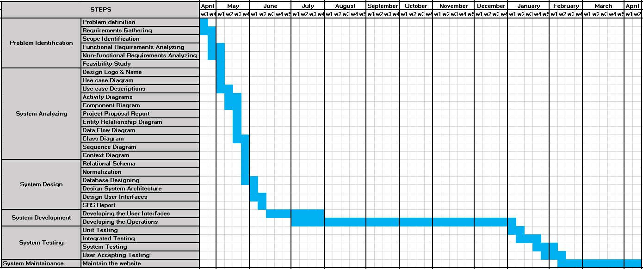

*Figure 02: Schedule feasibility graph*

## 5.5 Operational feasibility

* When we consider our project it is a really good solution for current requirements.
* When we consider the survey that we did, it is crystal clear that our solution for travel management will fulfill the requirements of the user.
* The user has to book a hotel and a vehicle for their journey. According to the survey, it is not easy to find those needs. So from our system, they have to only spend a few minutes to find a travel package and enter their details. The administrator will find all the other needs of them.
* When considering the proposed system, it will provide more benefits. Because the user has to pay the cost separately. But in our scenario, the cost will be based on the travel package. So it is economically benefited for the user.
* Not only the user, the other accounts hotel, guide, and the vehicle will also get benefits. If they are hiring themselves that will be a big cost more than they registered on this website. Because they have to have a method like a website to get hired. So the only thing they have to do is change their availability on this website. So they will get advantages from our website.

# 6. Deliverables of the project.

* In the System Analyzing phase, we are providing the proposal of the system. It will include the project scope, feasibility study, functional and non-functional requirements, etc.
* In the System Designing phase, we are going to provide the Software Requirement Specification (SRS) Document including database structure, wireframes, and the prototype.
* In the final stage, we are providing a working system with user documentation.

# 7. Methodology

## 7.1 Development Model

* We are going to use waterfall model as our development model.

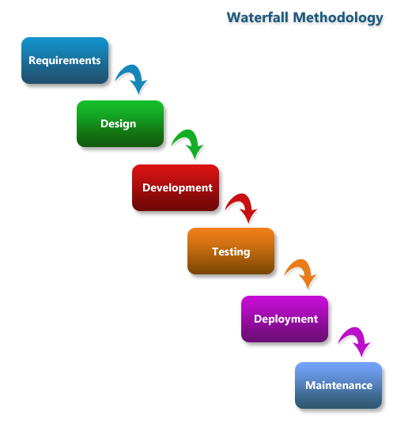

*Figure 02: Waterfall Model*

* Step 1: We gather requirements according to the problem that we identified. Here we have surveyed to identify the problem of society. Then we decided to have solutions for those issues.
* Step 2: Here we have to design our interfaces, database rationalities. As well we have to design the database with tables which are interacting with our system.
* Step 3: In this phase, we are going to implement our system. We have to implement the system that we designed in the designing phase.
* Step 4: In this phase, we are going to test our system to find bugs and errors and fix them.
* Step 5: We are planning to give our project for selected users and get their ideas about our project.
* Step 6: This phase will be used to further improve and maintain the system.

## 7.2 Reasons to select this development model

Considering the Second Year Group Project, we have the following reasons to select the Waterfall model as our development model.

1. It is milestone-focused development. The deadlines and guidelines for the project are analyzed. In the first milestone we have to provide all the requirements of the project. In the interim presentation which is the third milestone, we have to submit the finalize user interface and the finalize database. So there is no opportunity to change the user interfaces or the database which are developed in the design phase. Because of that, there is no opportunity to go back to the above phases from the current phase and change the functionalities of the system. So because of the workflow which is created according to the milestones, it will follow the Waterfall model.
2. We have to define the scope at the beginning of the project. So we have found clear requirements.
3. And also, we have identified the technologies for the project at the beginning. So those technologies can’t change during the development of time.

# 8. Project constraints and assumptions identification

## 8.1 Project constraints

### 8.1.1 Cost

* According to our proposed system, the development cost will be zero. But if we want to host the website we have to pay for the domain.
* As well now we are using a test model of a payment gateway but if we want to host the website we have to pay for the payment gateway.

### 8.1.2 Scope

* Under section 1.4.1 we provide the scope of our proposed website.

### 8.1.3 Quality

* From our proposed website users can give ratings for the various sections. Through that, the administrator can get an idea about the quality of the service which is given by the website.

### 8.1.4 Customer Satisfaction

* When the development of the project we have to implement a user-friendly environment.
* When considering the working website, the administrator has a responsibility to provide good service to the user.

### 8.1.5 Risk

* When the development of the project we have to submit the project in the given period of the time.
* When considering the working website, the administrator will face some risks of the conditions of the hotel and the vehicle
* As well the weather condition will be an issue sometimes.

### 8.1.6 Resources

* For the development of the proposed system, we are using our laptops, freely available tools, and open-source software.
* There will be four members to develop the proposed system.

### 8.1.7 Time

* We have only one year to do the proposed system. In that period we have to identify the problem, gather requirements, system designing, system implementation, system testing, and the maintenance of the system.

## 8.2 Assumptions

* During the development of the proposed system,
  + We have all the resources that we need to develop the proposed website.
  + All our equipment is in good condition.
  + Our team members have all the required skills.
* Considering the working website administrator will assume,
  + All the vehicles are in good condition.
  + All the hotels have good service and facilities.
  + The weather condition will not be an issue.
* Considering the technology,
  + We have all the required technology.
  + All the members learned about those technologies. If someone has a problem with some technologies, he will learn those within this period.
* Considering the finance of the proposed system,
  + The development cost will be zero.

# 9. Functional Requirement Identification

According to our proposed system, we can find the following requirements as functional requirements.

1. User Requirements

* User
  + Users must register to the system by creating an account.
  + The user will log in to the website by using his username and password.
  + Users can search for information about travel packages by entering the number of days, price of the package or location name.
  + Users can view travel packages with separating categories and subcategories.
  + Users can view the destinations.
  + Users can view his profile.
  + The user can update his profile.
  + Users can delete his profile.
  + Users can add comments.
  + Users can book travel packages with entering details.
  + Users can pay for the booked travel package.
  + Users can cancel the bookings within two days.
  + Users can send messages to admin, regarding issues.
* Hotel
  + Hotel users must register to the system by creating an account.
  + Hotel users will log in to the website by using his username and password.
  + Hotel users can view his profile.
  + The hotel user can update his profile.
  + Hotel users can delete his profile.
  + Hotel user can change the availability
* Guide
  + Guide users must register to the system by creating an account.
  + Guide user will log in to the website by using his username and the password.
  + Guide users can view his profile.
  + Guide users can update his profile.
  + Guide users can delete his profile.
  + Guide user can change the availability
* Vehicle
  + Vehicle users must register to the system by creating an account.
  + Vehicle users will log in to the website by using his username and password.
  + The vehicle user can view his profile.
  + The vehicle user can update his profile.
  + The vehicle user can delete his profile.
  + Vehicle user can change the availability

1. System Requirements

* The system can be able to store the details of bookings.
* The system should have different home pages for different user account types.
* The system will be able to generate reports.
* The system should be able to add, update, and delete travel packages.
* The system should be able to add, update and delete categories and subcategories.
* The system should be able to add a destination.
* The system should be able to search for accounts and view accounts.

## 9.1 Component diagram

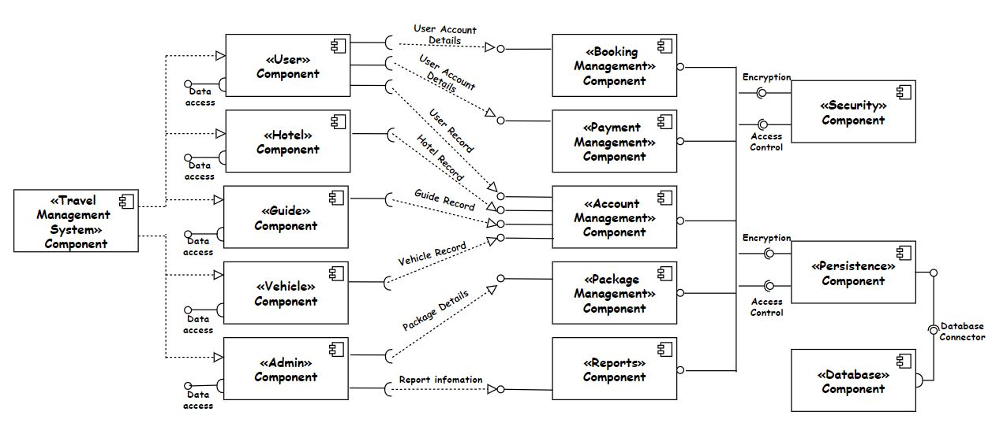

*Figure 04: Component Diagram*

## 9.2 Use case diagram

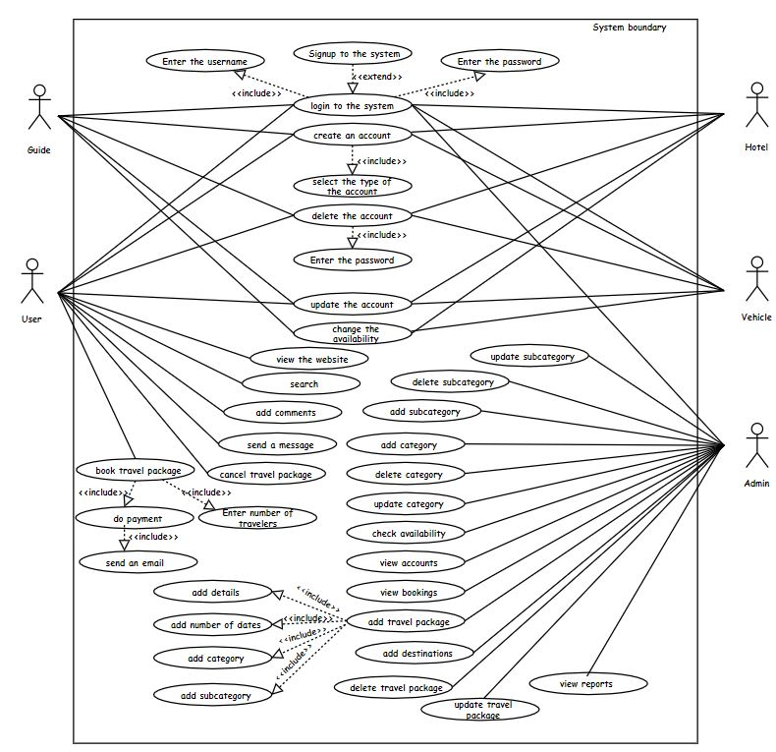

*Figure 05: Use case Diagram*

### 9.2.1 Actor wise use cases

1. 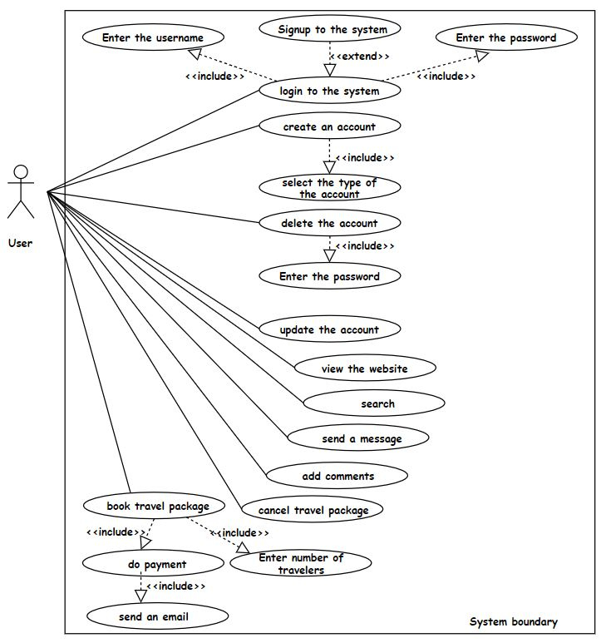User

*Figure 06: Use case Diagram for the user*

1. 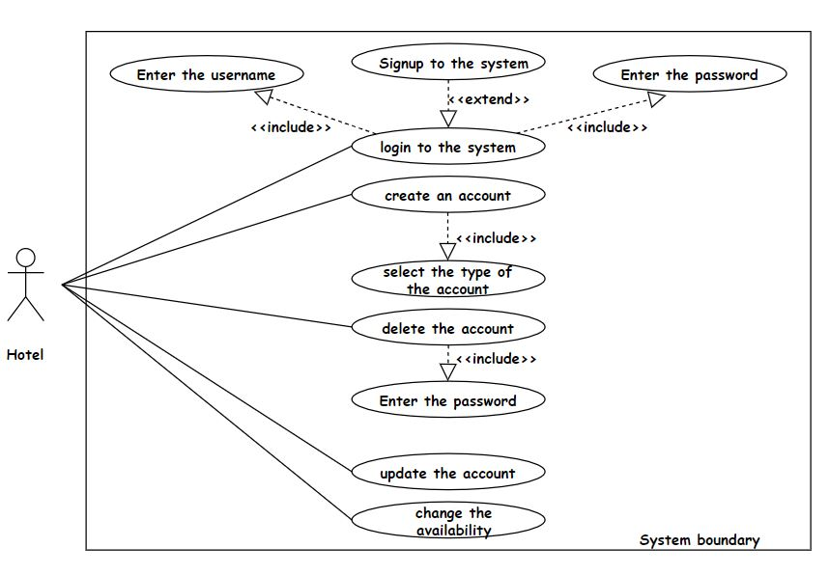Hotel

*Figure 07: Use case Diagram for the hotel*

1. 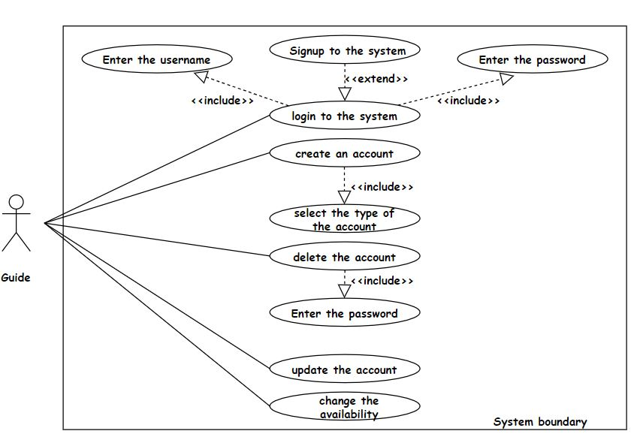 Guide

*Figure 08: Use case Diagram for the guide*

1. 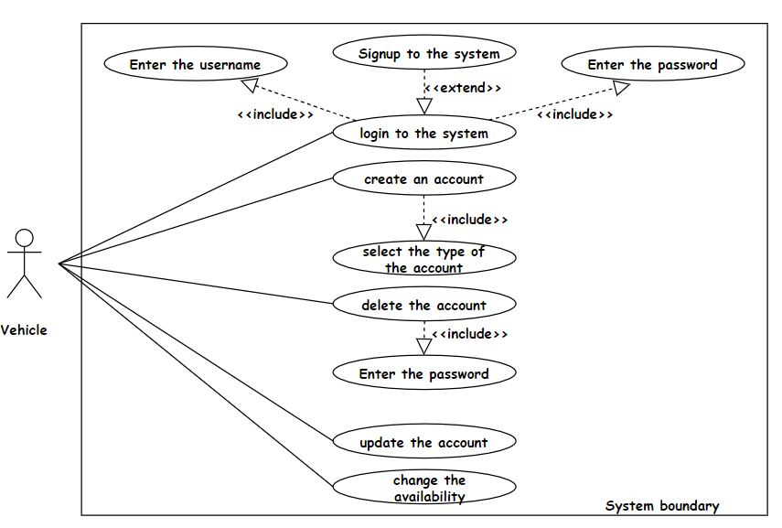Vehicle

*Figure 09: Use case Diagram for the vehicle*

1. 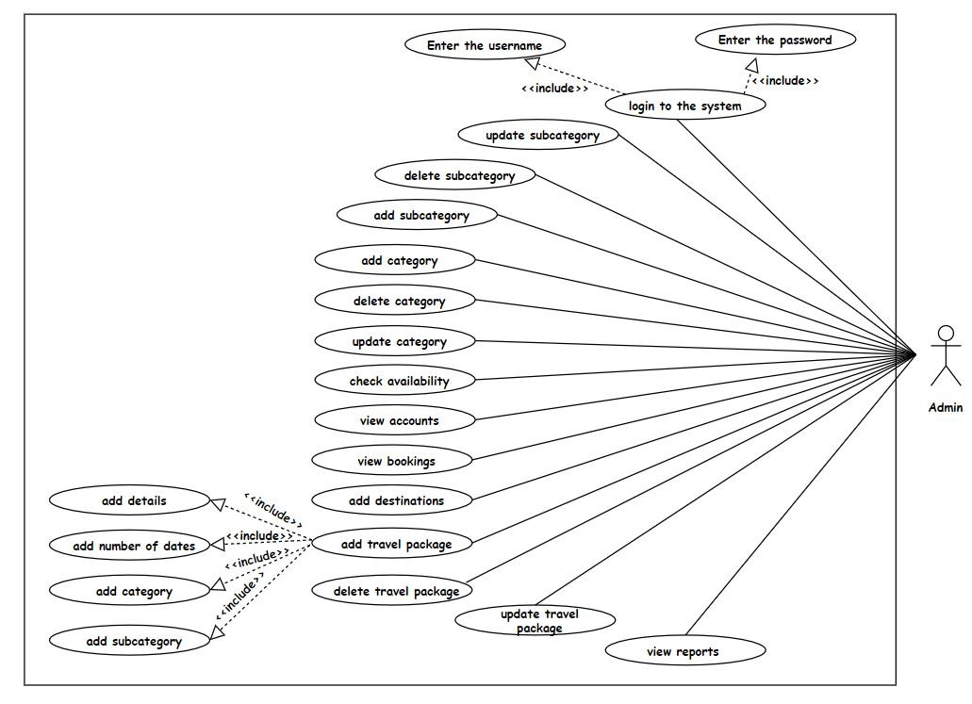Admin

*Figure 10: Use case Diagram for the admin*

## 9.3 Use case Descriptions

### 9.3.1 Use case descriptions for Admin’s functionalities.

|  |  |
| --- | --- |
| Use case | Login to the system |
| Summary | Admin logins into the system. |
| Actors | Admin |
| Preconditions | Admin should not be logged in to the system. |
| Description | Admin should enter the username and the password to login to the system. |
| Exceptions | Admin’s username and the password not in the system.  Admin already logs in to the system. |
| Post conditions | Admin logged in to the system.  Admin views the home page |

*Table 01: Use case description for admin logins into the system*

|  |  |
| --- | --- |
| Use case | View accounts |
| Summary | Admin views accounts’ profiles. |
| Actors | Admin |
| Preconditions | Admin should be logged in to the system by using the username and the password.  Admin should select the view profile and select the type of the accounts. |
| Description | Admin will see a list of accounts. Then admin can view the accounts’ profiles using their ids or names. From selecting the name of the account, the admin will be able to see more details of the corresponding account. |
| Exceptions | The selected profile does not exist in the system. |
| Post conditions | Admin will view the selected profile. |

*Table 02: Use case description for admin views accounts’ profiles.*

|  |  |
| --- | --- |
| Use case | View bookings |
| Summary | Admin views booking list. |
| Actors | Admin |
| Preconditions | Admin should be logged in to the system by using the username and the password.  Admin should select the view bookings. |
| Description | Admin can view the booking list. Then admin can enter booking id or date to find the booking. From that admin will get more details about the user and he will get the number of days and the number of people who will join the journey. |
| Exceptions | There is no booking available. |
| Post conditions | Admin will view the booking list and the more details of the selected booking. |

*Table 03: Use case description for admin views booking list.*

|  |  |
| --- | --- |
| Use case | View reports |
| Summary | Admin views the reports. |
| Actors | Admin |
| Preconditions | Admin should be logged in to the system by using the username and the password.  Admin should select the view reports. |
| Description | Admin can view the reports like the number of travelers for a travel package, best hotels, best guides, the best vehicle, best travel package, etc. First admin has to select the report. After that he will see the report’s details. |
| Exceptions | There are no details to generate reports. |
| Post conditions | Admin will view the selected report’s details. |

*Table 04: Use case description for admin views the reports.*

|  |  |
| --- | --- |
| Use case | Add travel package |
| Summary | Admin adds a new travel package to the system |
| Actors | Admin |
| Preconditions | Admin should be logged in to the system by using the username and the password.  Admin should select the add travel package. |
| Description | Admin can add a new travel package to the system by choosing category and subcategory. Admin has to enter details of the travel plan and the number of days. As well the admin has to enter the price of the travel package for a single person. |
| Exceptions | Admin is not logged in to the system. |
| Post conditions | A message of “successfully added” will appear. |

*Table 05: Use case description for admin adds a travel package.*

|  |  |
| --- | --- |
| Use case | Add category |
| Summary | Admin adds the categories of the travel package to the system |
| Actors | Admin |
| Preconditions | Admin should be logged in to the system by using the username and the password.  Admin should select the add category. |
| Description | Admin can add a new category for the travel package by entering its name. Then the system will automatically give an id number to that category. |
| Exceptions | The added category exists in the system. |
| Post conditions | A message of “successfully added” will appear. |

*Table 06: Use case description for admin adds a category*

|  |  |
| --- | --- |
| Use case | Add subcategory |
| Summary | Admin adds the subcategories of the travel package to the system |
| Actors | Admin |
| Preconditions | Admin should be logged in to the system by using the username and the password.  Admin should select the add subcategory. |
| Description | First admin should have selected the category of the new subcategory. Then admin can add a new subcategory for the travel package by using its name. Then the system will automatically give an id number to that subcategory. |
| Exceptions | The added subcategory exists in the system. |
| Post conditions | A message of “successfully added” will appear. |

*Table 07: Use case description for admin adds a subcategory*

|  |  |
| --- | --- |
| Use case | Add destinations |
| Summary | Admin adds the destination into the system. |
| Actors | Admin |
| Preconditions | Admin should be logged in to the system by using the username and the password.  Admin should select the add destinations. |
| Description | Admin can add a new destination including the details and photos.  Then the system will automatically give an id number to that destination. |
| Exceptions | The added destination name exists in the system. |
| Post conditions | A message of “successfully added” will appear. |

*Table 08: Use case description for admin adds a destination*

|  |  |
| --- | --- |
| Use case | Check availability |
| Summary | Admin checks the availability of hotels, guides, and vehicles |
| Actors | Admin |
| Preconditions | Admin should be logged in to the system by using the username and the password.  Admin should select view availability of the wanted account type. |
| Description | Admin can view a list of registered accounts according to the selected account type. In this list, the admin can view the available accounts. Then admin can get more details by selecting one of those accounts. |
| Exceptions | There are no registered accounts of the selected account types. |
| Post conditions | The list of selected and available accounts will be displayed. |

*Table 09: Use case description for admin checks availability*

|  |  |
| --- | --- |
| Use case | Delete a category |
| Summary | Admin deletes a category. |
| Actors | Admin |
| Preconditions | Admin should be logged in to the system by using the username and the password.  Admin should select the delete category. |
| Description | Admin will delete a category selecting its id number. Then he will see the details of the category. Then there will be a confirmation of the deletion again. After the admin will confirm the deletion the category will be deleted. |
| Exceptions | The category id is not in the system. |
| Post conditions | A message of “successfully deleted” will appear. |

*Table 10: Use case description for admin deletes a category*

|  |  |
| --- | --- |
| Use case | Delete a subcategory |
| Summary | Admin deletes a subcategory. |
| Actors | Admin |
| Preconditions | Admin should be logged in to the system by using the username and the password.  Admin should select the delete subcategory. |
| Description | Admin will delete a subcategory selecting its id number. Then he will see the details of the subcategory. Then there will be a confirmation of the deletion again. After admin will confirm the deletion the subcategory will be deleted. |
| Exceptions | The subcategory id is not in the system. |
| Post conditions | A message of “successfully deleted” will appear. |

*Table 11: Use case description for admin deletes a subcategory*

|  |  |
| --- | --- |
| Use case | Delete a travel package |
| Summary | Admin deletes the travel package. |
| Actors | Admin |
| Preconditions | Admin should be logged in to the system by using the username and the password.  Admin should select the delete travel package. |
| Description | Admin will delete a travel package selecting its id number. Then he will see the details of the travel package. Then there will be a confirmation of the deletion again. After the admin will confirm the deletion the travel package will be deleted. |
| Exceptions | The travel package id is not in the system. |
| Post conditions | A message of “successfully deleted” will appear. |

*Table 12: Use case description for admin deletes a travel package*

|  |  |
| --- | --- |
| Use case | Update category |
| Summary | Admin updates the category. |
| Actors | Admin |
| Preconditions | Admin should be logged in to the system by using the username and the password.  Admin should select the update category. |
| Description | Admin updates the category name by selecting its id. |
| Exceptions | The updated category does not exist in the system. |
| Post conditions | A message of “successfully updated” will appear. |

*Table 13: Use case description for admin updates a category*

|  |  |
| --- | --- |
| Use case | Update subcategory |
| Summary | Admin updates the subcategory. |
| Actors | Admin |
| Preconditions | Admin should be logged in to the system by using the username and the password.  Admin should select the update subcategory. |
| Description | Admin updates the subcategory name by selecting its id. |
| Exceptions | The update subcategory does not exist in the system. |
| Post conditions | A message of “successfully updated” will appear. |

*Table 14: Use case description for admin updates a subcategory*

|  |  |
| --- | --- |
| Use case | Update travel package |
| Summary | Admin updates the travel package. |
| Actors | Admin |
| Preconditions | Admin should be logged in to the system by using the username and the password.  Admin should be selected the update travel package. |
| Description | Admin updates the travel package's details selecting its id. Then he can change details about the travel package. |
| Exceptions | The updated travel package does not exist in the system. |
| Post conditions | A message of “successfully updated” will appear. |

*Table 15: Use case description for admin updates a travel package*

### 9.3.2 Use case descriptions for User’s functionalities.

|  |  |
| --- | --- |
| Use case | Log in to the system |
| Summary | User logins into the system |
| Actors | User |
| Preconditions | The user should not be logged in to the system by using the username and the password.  The user should select the login. |
| Description | The user will have to enter the username and the password to login into the system. |
| Exceptions | The user is not registered in the system.  The user already logs into the system. |
| Post-conditions | User logged in to the system |

*Table 16: Use case description for user logins into the system*

|  |  |
| --- | --- |
| Use case | Create an account |
| Summary | User registers to the system using the account type of user. |
| Actors | User |
| Preconditions | The user should not have an account in the system by using the username and the password.  The user has to select the account type as the “user”. |
| Description | User will get a form to fill his information for registration to the website. After he submitted the details he will be a registered user in the system. |
| Exceptions | The user has an account with the same details like email. |
| Post-conditions | User will get the home page. |

*Table 17: Use case description for user creates an account*

|  |  |
| --- | --- |
| Use case | Add comments |
| Summary | The user adds comments about the travel package. |
| Actors | User |
| Preconditions | The user should be logged in to the system by using the username and the password.  User should select the view profile and add comments. |
| Description | The user will comment on the travel packages and add photos. There is an option to give ratings for the hotel, vehicle, and the guide as well. |
| Exceptions | The user is not logged in to the system. |
| Post-conditions | The user can input the comments to the system. |

*Table 18: Use case description for user adds comments*

|  |  |
| --- | --- |
| Use case | Book travel package |
| Summary | User books a travel package. |
| Actors | User |
| Preconditions | The user should be logged in to the system by using the username and the password. |
| Description | First user has to select the category and the subcategory of the package. Then he will find travel packages under the subcategory. Pressing the “Book Now” button, the user can view a form to fill. After entering the details he will be able to book a travel package. |
| Exceptions | The user is not logged in to the system. |
| Post-conditions | The user will see the payment options for the booked travel package. |

*Table 19: Use case description for user books travel package*

|  |  |
| --- | --- |
| Use case | Cancel the booking |
| Summary | The user cancels the booking which he made before. |
| Actors | User |
| Preconditions | The user should be logged in to the system by using the username and the password.  The date of cancelation should be within two dates starting the booking date.  The user should select the view profile and view bookings. |
| Description | User can view the booking which had done by him. Then he will click the name and he cancel the booking by clicking the “cancel” button. After confirming the cancelling the booking will be canceled. |
| Exceptions | The user is not logged in to the system.  User not book a travel package.  The cancelation date is after two dates of the booking date. |
| Post-conditions | The user gets a message for canceling the booking. |

*Table 20: Use case description for user cancels the booking*

|  |  |
| --- | --- |
| Use case | Delete the account |
| Summary | User can delete his account which includes his details from the system. |
| Actors | User |
| Preconditions | The user should be logged in to the system by using the username and the password.  The user should select the view profile. |
| Description | The user can delete his account by clicking the “delete profile” button. After that he has to enter the password of his account. Then there will be a confirmation. After confirming that he will be able to delete the account from the system. |
| Exceptions | The user is not logged in to the system. |
| Post-conditions | The user gets a message for deleting his account. |

*Table 21: Use case description for user deletes the account*

|  |  |
| --- | --- |
| Use case | Do payment |
| Summary | User pay for the booking travel package. |
| Actors | User |
| Preconditions | The user should be logged in to the system by using the username and the password.  The user should book a travel package before the payment. |
| Description | User can pay for the booking travel package using his bank details. |
| Exceptions | The user is not logged in to the system.  The user is not booked a travel package. |
| Post-conditions | The user gets a message for payment. |

*Table 22: Use case description for user does the payment*

|  |  |
| --- | --- |
| Use case | Search |
| Summary | User search travel packages. |
| Actors | User |
| Preconditions | The user should go to the website it doesn't matter whether he logs in to the system or not. |
| Description | The user search travel packages by entering the number of days, places, or the price of the travel package. |
| Exceptions | User is not on the home page. |
| Post-conditions | User will see the filtered packages |

*Table 23: Use case description for user searches*

|  |  |
| --- | --- |
| Use case | Update the account |
| Summary | The user updates the profile. |
| Actors | User |
| Preconditions | The user should be logged in to the system by using the username and the password.  The user should select the view profile. |
| Description | The user updates his profile by clicking the “update profile” button. After that user will see the details of the profile and he will be able to update details. |
| Exceptions | The user is not logged in to the system. |
| Post-conditions | User will get a message for updating. |

*Table 24: Use case description for user updates the account*

|  |  |
| --- | --- |
| Use case | View [not registered user] |
| Summary | The user views the website. |
| Actors | User |
| Preconditions | The user should not be logged in to the system by using the username and the password. |
| Description | The user will see the options to view the packages by selecting category and the subcategory, view comments, view destinations, and view about us. |
| Exceptions | The user is logged in to the system. |
| Post-conditions | User will see the viewed item. |

*Table 25: Use case description for user [not registered user] views*

|  |  |
| --- | --- |
| Use case | View [registered user] |
| Summary | The user views the website. |
| Actors | User |
| Preconditions | The user should be logged in to the system. |
| Description | The user will see the options to view the packages by selecting category and the subcategory, view comments, view destinations, view profile, and view about us. |
| Exceptions | The user is not logged in to the system. |
| Post-conditions | User will see the viewed item. |

*Table 26: Use case description for user [registered user] views*

|  |  |
| --- | --- |
| Use case | Send message |
| Summary | The user sends messages to the administrator regarding something. |
| Actors | User |
| Preconditions | The user should be on the home page. It doesn’t matter whether the user is registered or not.  The user should select the contact page. |
| Description | User will see a form and he will enter his contact details and the message. After that he has to click on the “send” button. |
| Exceptions | The user is not on the website. |
| Post-conditions | User will get a message for sending. |

*Table 27: Use case description for user sends a message*

### 9.3.3 Use case descriptions for Guide’s functionalities.

*Table 28: Use case description for guide login into the system*

*Table 29: Use case description for guide creates and account*

|  |  |
| --- | --- |
| Use case | Log in to the system |
| Summary | Guide logins into the system |
| Actors | Guide |
| Preconditions | The guide should not be logged in to the system.  The guide should select the login. |
| Description | The guide will have to enter the username and the password to login to the system. |
| Exceptions | Guide’s username and the password not in the system.  The guide already logs in to the system. |
| Post-conditions | Guide logged in to the system. |

|  |  |
| --- | --- |
| Use case | Create an account |
| Summary | Guide registers to the system using the account type of “guide”. |
| Actors | Guide |
| Preconditions | The guide should not have an account in the system.  The guide should be selected the account type as “guide” |
| Description | The guide will get a form to fill his information for registration to the website. |
| Exceptions | The guide has an account with the same details like email. |
| Post-conditions | Guide views the home page. |

|  |  |
| --- | --- |
| Use case | Update the account |
| Summary | Guide update the profile. |
| Actors | Guide |
| Preconditions | The guide should be logged in to the system by using the username and the password.  The guide should select the view profile. |
| Description | The guide updates his profile by clicking the “update profile” button. After that the guide will see the details of the profile and he will be able to update details. |
| Exceptions | The guide is not logged in to the system. |
| Post-conditions | The guide will get a message for updating. |

*Table 30: Use case description for guide updates the profile*

|  |  |
| --- | --- |
| Use case | Delete the account |
| Summary | The guide can delete his account which includes his details from the system. |
| Actors | Guide |
| Preconditions | The guide should be logged in to the system by using the username and the password.  The guide should select the view profile. |
| Description | The guide can delete his account by clicking the “delete profile” button. After that he has to enter the password of his account. Then there will be a confirmation. After confirming that he will be able to delete the account from the system. |
| Exceptions | The guide is not logged in to the system. |
| Post-conditions | Guide gets a message for deleting his account. |

*Table 31: Use case description for guide deletes the account*

|  |  |
| --- | --- |
| Use case | Change availability |
| Summary | The guide can input whether he is available or not available. |
| Actors | Guide |
| Preconditions | The guide should be logged in to the system by using the username and the password.  The guide should be selected the view profile. |
| Description | The guide will see an option as “change availability”. After clicking that the guide will be able to change the availability. |
| Exceptions | The guide is not logged in to the system. |
| Post-conditions | The guide will see a message of changing the availability. |

*Table 32: Use case description for guide changes availability*

### 9.3.4 Use case descriptions for the hotel's functionalities.

|  |  |
| --- | --- |
| Use case | Log in to the system |
| Summary | Hotel logins into the system |
| Actors | Hotel |
| Preconditions | The hotel should not be logged in to the system.  The hotel should select the login. |
| Description | The hotel will have to enter the username and the password to login to the system. |
| Exceptions | Hotel’s username and the password not in the system.  The hotel already logs in to the system. |
| Post-conditions | Hotel logged in to the system. |

*Table 33: Use case description for hotel logins into the system*

|  |  |
| --- | --- |
| Use case | Create an account |
| Summary | Hotel registers to the system using the account type of “hotel”. |
| Actors | Hotel |
| Preconditions | The hotel should not have an account in the system.  The hotel should be selected the account type as “hotel ” |
| Description | The hotel will get a form to fill his information for register to the website. |
| Exceptions | The hotel has an account with the same details like email. |
| Post-conditions | The hotel views the home page. |

*Table 34: Use case description for hotel creates an account*

|  |  |
| --- | --- |
| Use case | Update the account |
| Summary | Hotel updates the profile. |
| Actors | Hotel |
| Preconditions | The hotel should be logged in to the system by using the username and the password.  The hotel should select the view profile. |
| Description | The hotel updates his profile by clicking the “update profile” button. After that the hotel will see the details of the profile and he will be able to update details. |
| Exceptions | The hotel is not logged in to the system. |
| Post-conditions | The hotel will get a message for updating. |

*Table 35: Use case description for hotel updates the account*

|  |  |
| --- | --- |
| Use case | Delete the account |
| Summary | The hotel can delete his account which includes his details from the system. |
| Actors | Hotel |
| Preconditions | The hotel should be logged in to the system by using the username and the password.  The hotel should select the view profile. |
| Description | The hotel can delete his account by clicking the “delete profile” button. After that he has to enter the password of his account. Then there will be a confirmation. After confirming that he will be able to delete the account from the system. |
| Exceptions | The hotel is not logged in to the system. |
| Post-conditions | The hotel gets a message for deleting his account. |

*Table 36: Use case description for hotel deletes the account*

|  |  |
| --- | --- |
| Use case | Change availability |
| Summary | The hotel can input whether he is available or not available. |
| Actors | Hotel |
| Preconditions | The hotel should be logged in to the system by using the username and the password.  The hotel should select the view profile. |
| Description | The hotel will see an option as “change availability”. After clicking that the hotel will be able to change the availability. Hotel has to enter the available number of rooms according to its type. |
| Exceptions | The hotel is not logged in to the system. |
| Post-conditions | The hotel will see a message of changing the availability. |

*Table 37: Use case description for hotel changes availability*

### 9.3.5 Use case descriptions for vehicle’s functionalities.

*Table 38: Use case description for vehicle logins into the system*

|  |  |
| --- | --- |
| Use case | Create an account |
| Summary | Vehicle registers to the system using the account type of “vehicle”. |
| Actors | Vehicle |
| Preconditions | The vehicle should not have an account in the system.  The vehicle should select the account type as “vehicle ” |
| Description | The vehicle will get a form to fill his information for registration to the website. |
| Exceptions | The vehicle has an account with the same details like email. |
| Post-conditions | The vehicle views the home page. |

*Table 39: Use case description for vehicle creates an account*

|  |  |
| --- | --- |
| Use case | Update the account |
| Summary | The vehicle updates the profile. |
| Actors | Vehicle |
| Preconditions | The vehicle should be logged in to the system by using the username and the password.  The vehicle should select the view profile. |
| Description | The vehicle updates his profile by clicking the “update profile” button. After that hotel will see the details of the profile and he will be able to update details. |
| Exceptions | The vehicle is not logged in to the system. |
| Post-conditions | The vehicle will get a message for updating. |

|  |  |
| --- | --- |
| Use case | Log in to the system |
| Summary | Vehicle logins into the system |
| Actors | Vehicle |
| Preconditions | The vehicle should not be logged in to the system.  The vehicle should select the login. |
| Description | The vehicle will have to enter the username and the password to login to the system. |
| Exceptions | Vehicle’s username and the password not in the system.  The vehicle already logs in to the system. |
| Post-conditions | The vehicle logged in to the system. |

*Table 40: Use case description for vehicle updates the account*

|  |  |
| --- | --- |
| Use case | Delete the account |
| Summary | The vehicle can delete his account which includes his details from the system. |
| Actors | Vehicle |
| Preconditions | The vehicle should be logged in to the system by using the username and the password.  The vehicle should select the view profile. |
| Description | The vehicle can delete his account by clicking the “delete profile” button. After that he has to enter the password of his account. Then there will be a confirmation. After confirming that he will be able to delete the account from the system. |
| Exceptions | The vehicle is not logged in to the system. |
| Post-conditions | The vehicle gets a message for deleting his account. |

*Table 41: Use case description for vehicle deletes the account*

|  |  |
| --- | --- |
| Use case | Change availability |
| Summary | The vehicle can input whether he is available or not available. |
| Actors | Vehicle |
| Preconditions | The vehicle should be logged in to the system by using the username and the password.  The vehicle should select the view profile. |
| Description | The vehicle will see an option as “change availability”. After clicking that the vehicle will be able to change the availability. |
| Exceptions | The vehicle is not logged in to the system. |
| Post-conditions | The vehicle will see a message of changing the availability. |

*Table 42: Use case description for vehicle changes availability*

## 9.4 Activity Diagrams

### 9.4.1 Activity diagrams for User

#### 9.4.1.1 Login to the system

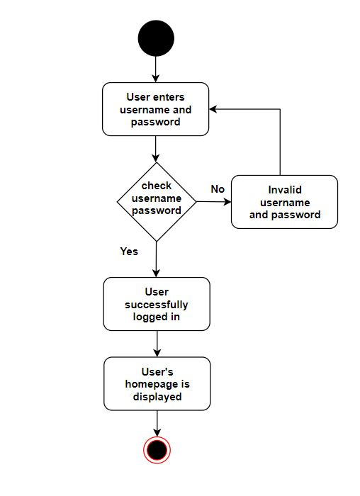

*Figure 11: User login to the system*

#### 9.4.1.2 Create an account

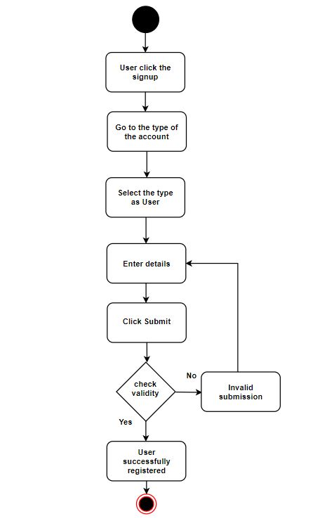

*Figure 12: User creates an account*

#### 9.4.1.3 Add comments

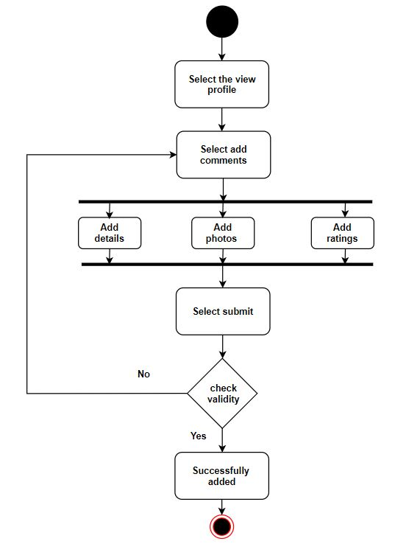

*Figure 13: User adds comments*

#### 9.4.1.4 Book travel package

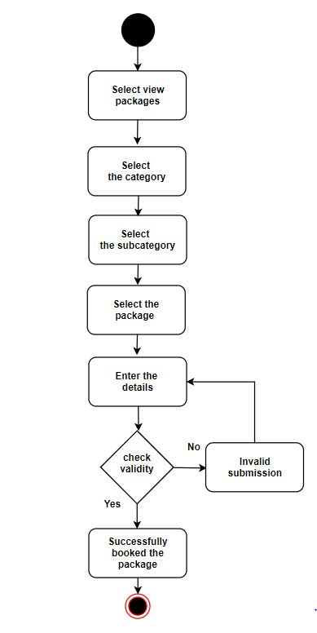

*Figure 14: User books travel package*

#### 9.4.1.5 Cancel the booking

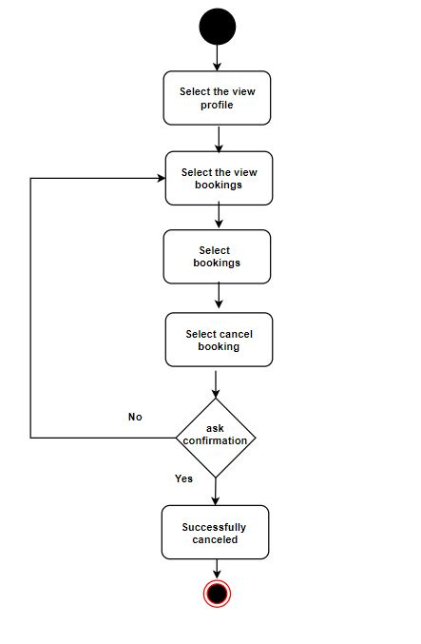

*Figure 15: User cancels the booking*

#### 9.4.1.6 Delete the account

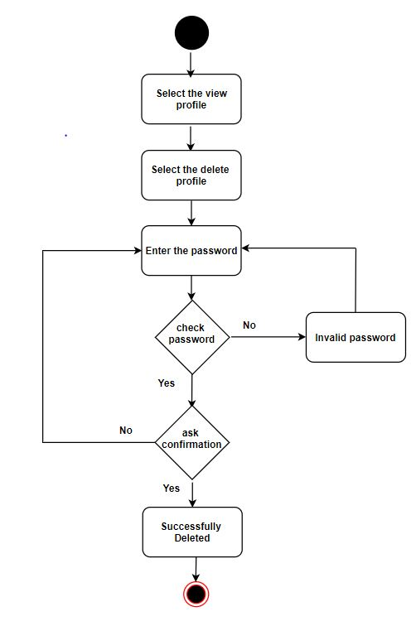

*Figure 16: User deletes the account*

#### 9.4.1.7 Do payment

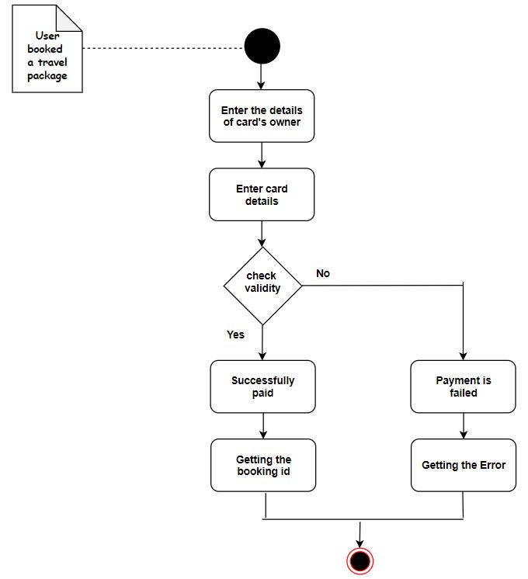

*Figure 17: User does the payment*

#### 9.4.1.8 Search

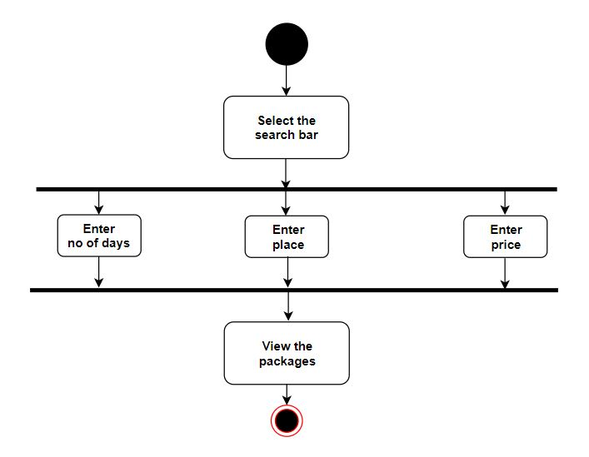

*Figure 18: User search*

#### 9.4.1.9 Update the account

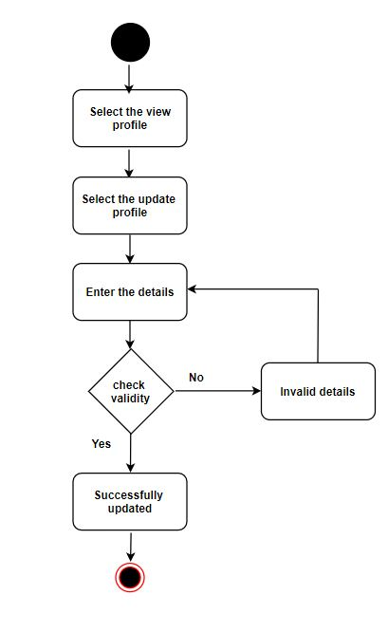

*Figure 19: User updates the account*

#### 9.4.1.10 View [not registered user]

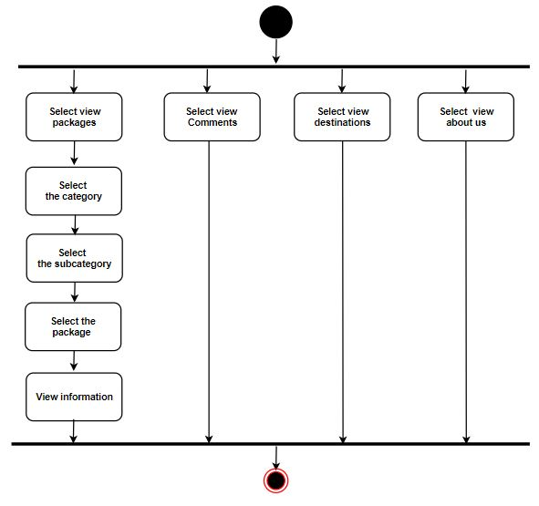

*Figure 20: User view [not registered user]*

#### 9.4.1.11 View [registered user]

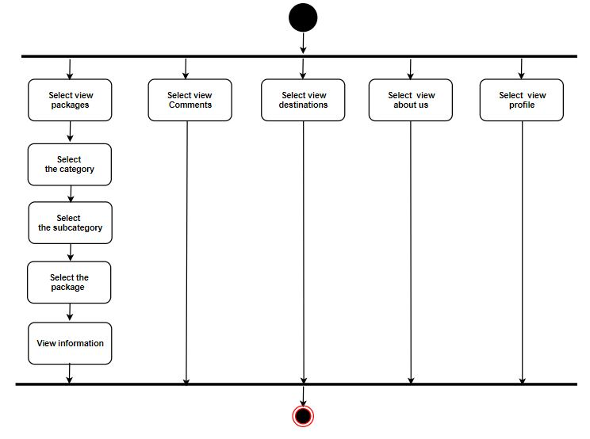

*Figure 21: User view [registered user]*

#### 9.4.1.12 User sends message

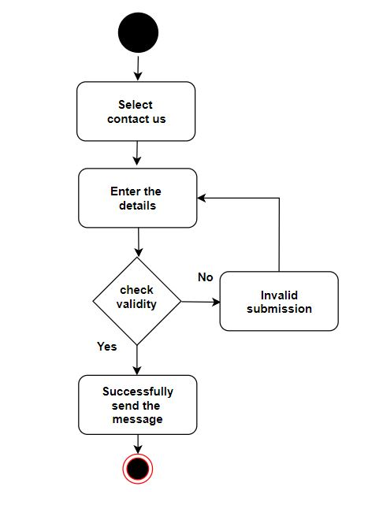

*Figure 22: User sends message*

### 9.4.2 Activity diagrams for Admin

#### 9.4.2.1 Login to the system

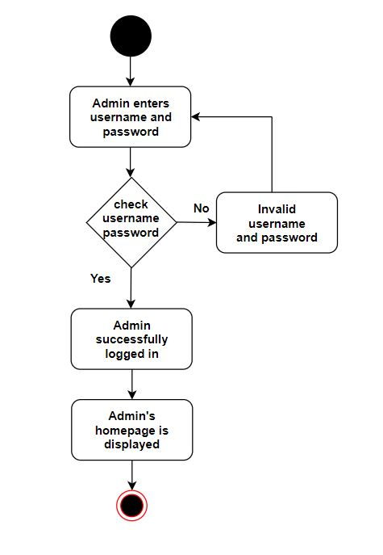

*Figure 23: Admin login to the system*

#### 9.4.2.2 View accounts

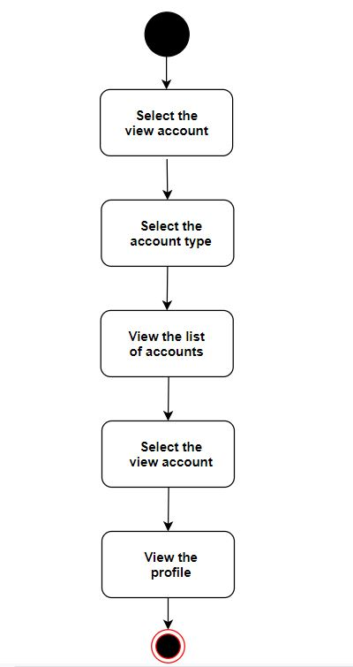

*Figure 24: Admin views accounts*

#### 9.4.2.3 View bookings

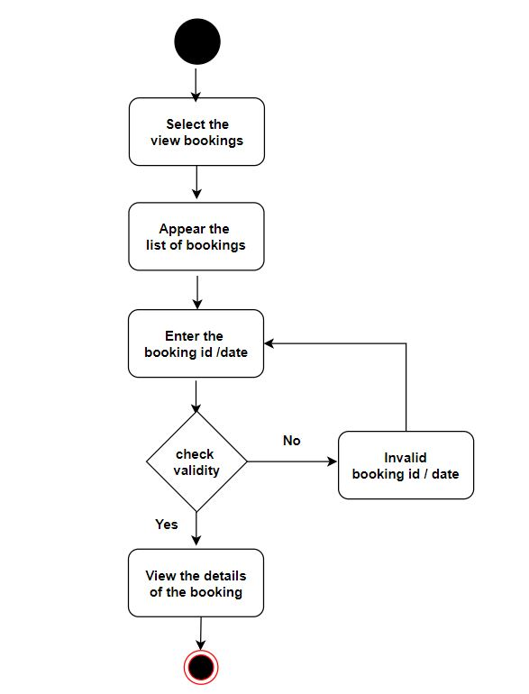

*Figure 25: Admin views bookings*

#### 9.4.2.4 View reports

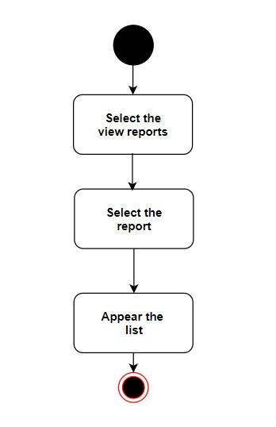

*Figure 26: Admin views reports*

#### 9.4.2.5 Add travel package

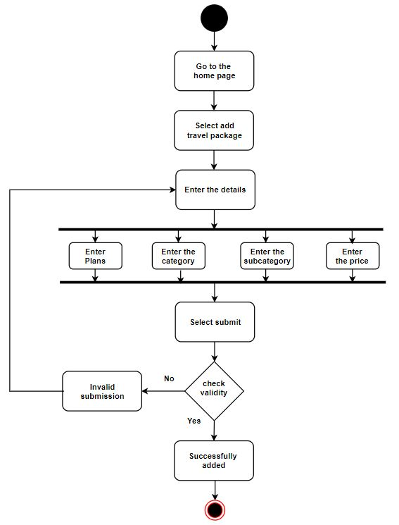

*Figure 27: Admin adds travel package*

#### 9.4.2.6 Add category

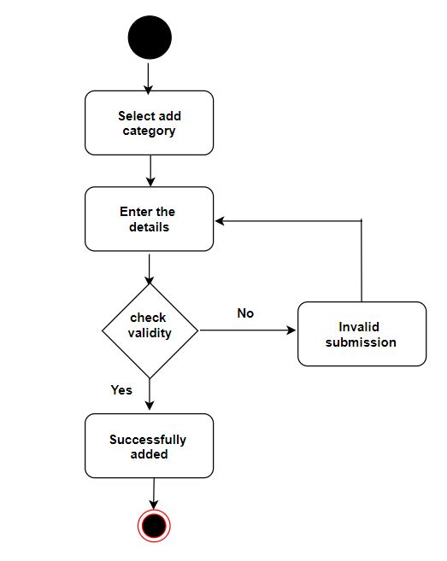

*Figure 28: Admin adds category*

#### 9.4.2.7 Add subcategory

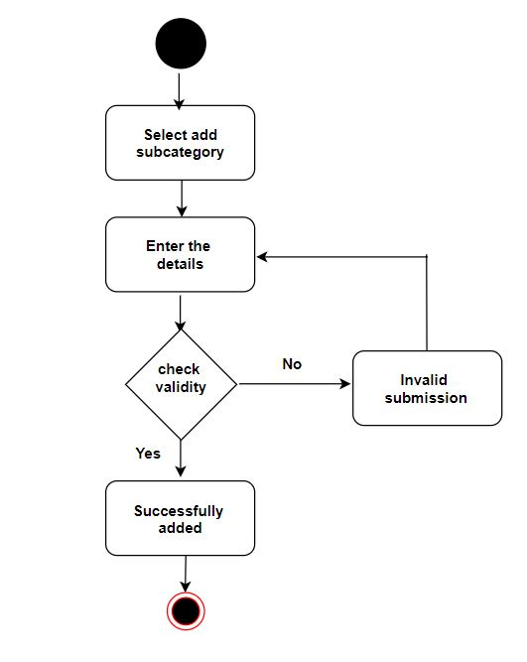

*Figure 29: Admin adds subcategory*

#### 9.4.2.8 Add destinations

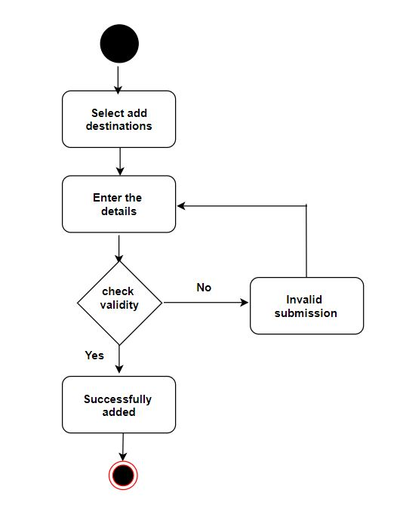

*Figure 30: Admin adds destinations*

#### 9.4.2.9 Check availability

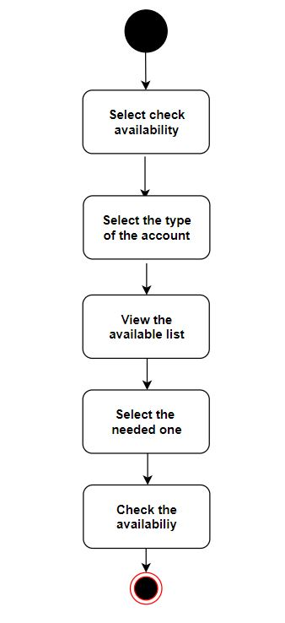

*Figure 31: Admin checks availability*

#### 9.4.2.10 Delete a category

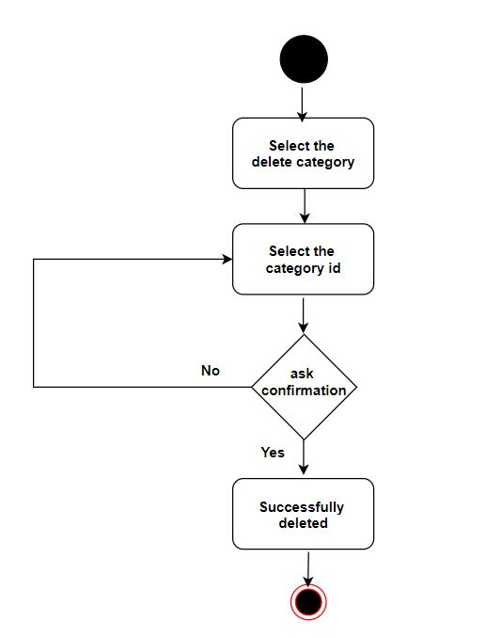

*Figure 32: Admin deletes category*

#### 9.4.2.11 Delete a subcategory

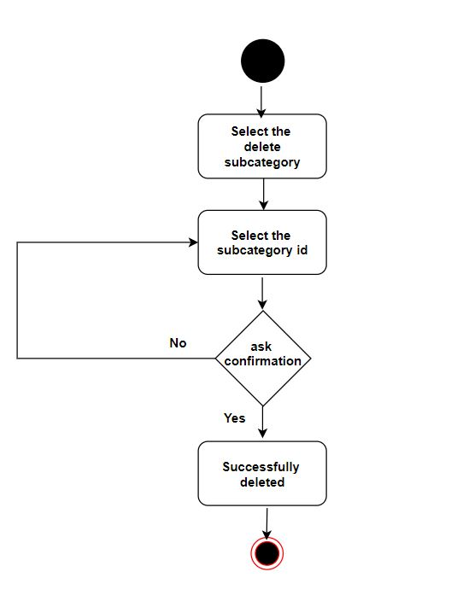

*Figure 33: Admin deletes subcategory*

#### 9.4.2.12 Delete a travel package

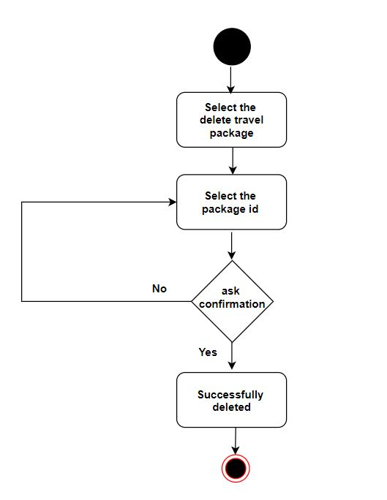

*Figure 34: Admin deletes travel package*

#### 9.4.2.13 Update category

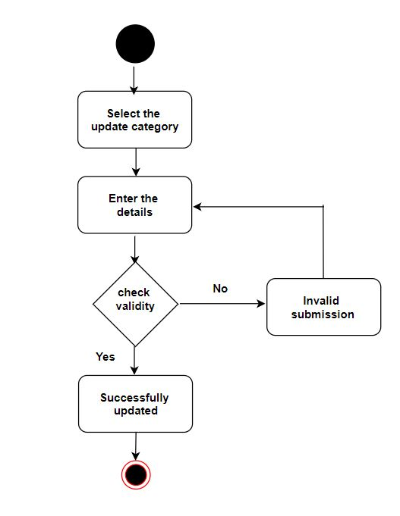

*Figure 35: Admin updates category*

#### 9.4.2.14 Update subcategory

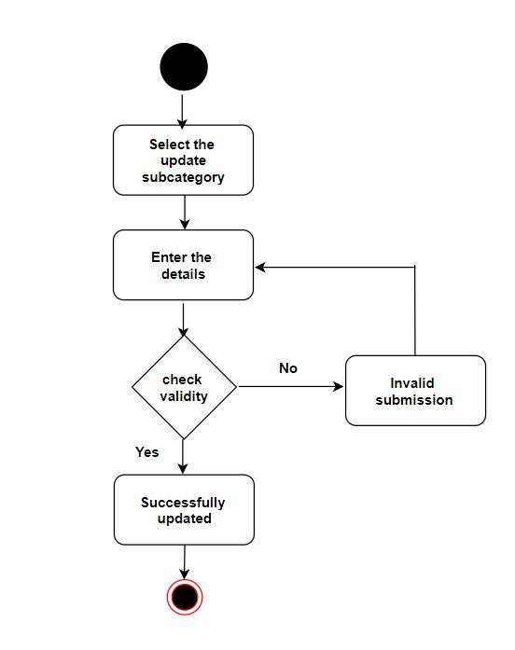

*Figure 36: Admin updates subcategory*

#### 9.4.2.15 Update travel package

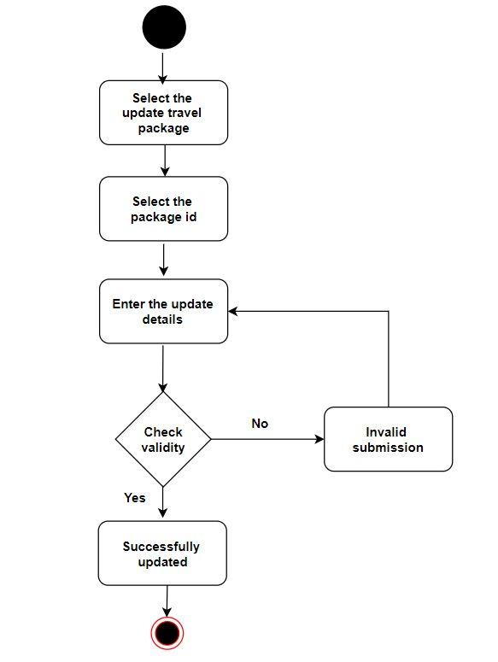

*Figure 37: Admin updates travel package*

### 9.4.3 Activity diagrams for Hotel

#### 9.4.3.1 Login to the system

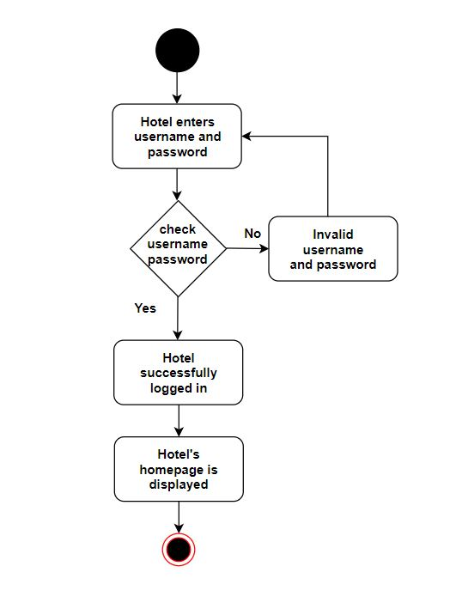

*Figure 38: Hotel login to the system*

#### 9.4.3.2 Create an account

#### 

*Figure 39: Hotel creates an account*

#### 9.4.3.3 Update the account

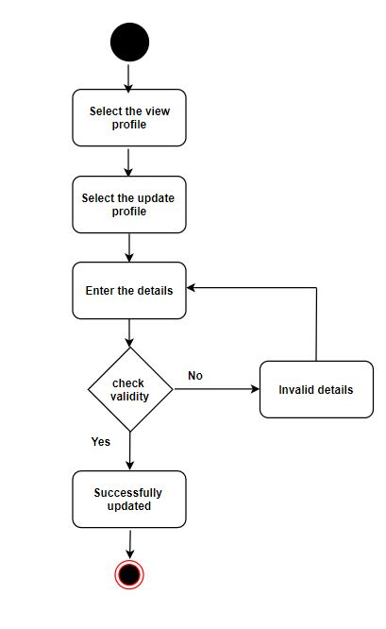

*Figure 40: Hotel updates the account*

#### 9.4.3.4 Delete the account



*Figure 41: Hotel deletes the account*

#### 9.4.3.5 Change availability

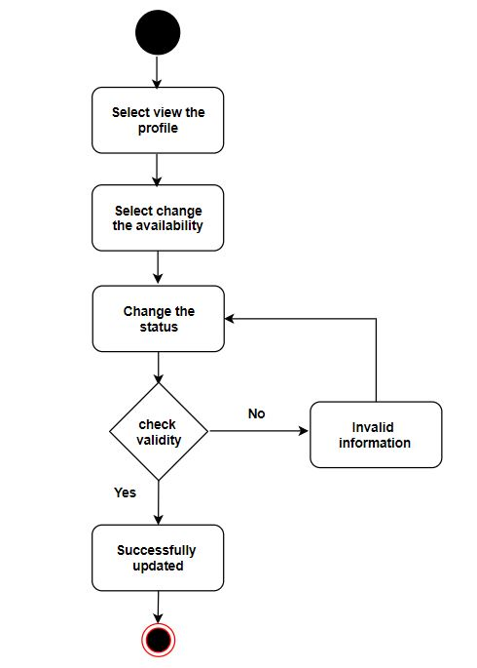

*Figure 42: Hotel changes the availability*

### 9.4.4 Activity diagrams for Guide

#### 9.4.4.1 Login to the system

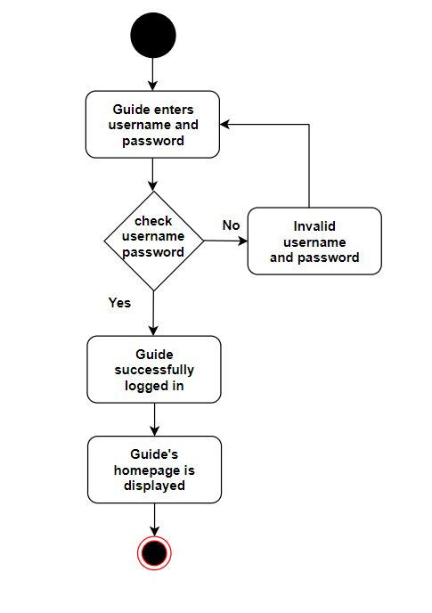

*Figure 43: Guide login to the system*

#### 9.4.4.2 Create an account

#### 

*Figure 44: Guide creates an account*

#### 9.4.4.3 Update the account

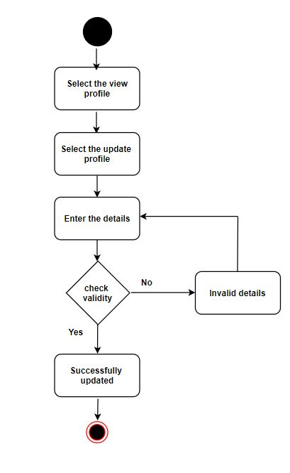

*Figure 45: Guide updates the account*

#### 9.4.4.4 Delete the account



*Figure 46: Guide deletes the account*

#### 9.4.4.5 Change availability

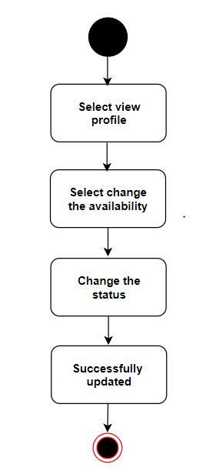

*Figure 47: Guide changes the availability*

### 9.4.5 Activity diagrams for Vehicle

#### 9.4.5.1 Login to the system

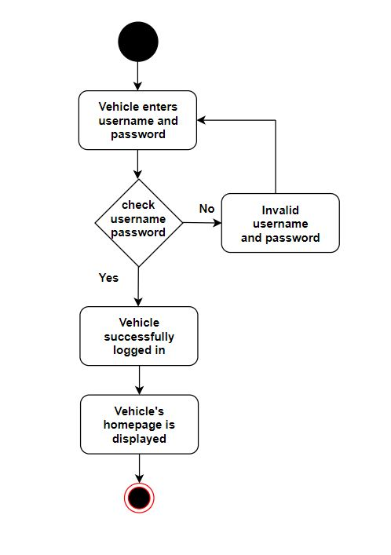

*Figure 48: Vehicle login to the system*

#### 9.4.5.2 Create an account

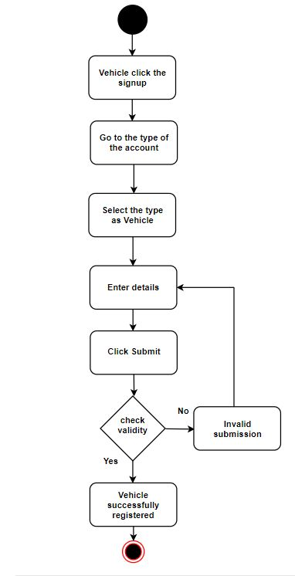

*Figure 49: Vehicle creates an account*

#### 9.4.5.3 Update the account

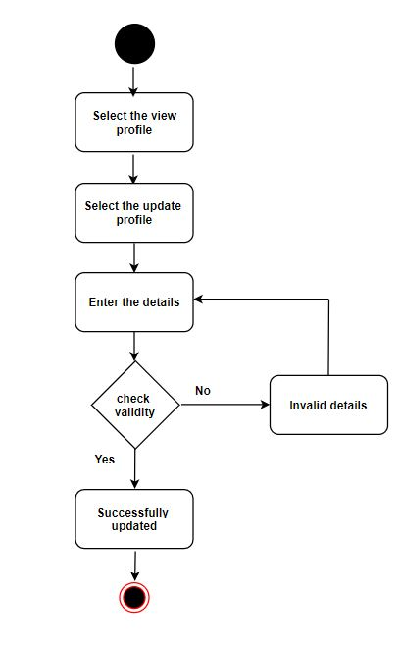

*Figure 50: Vehicle updates the account*

#### 9.4.5.4 Delete the account

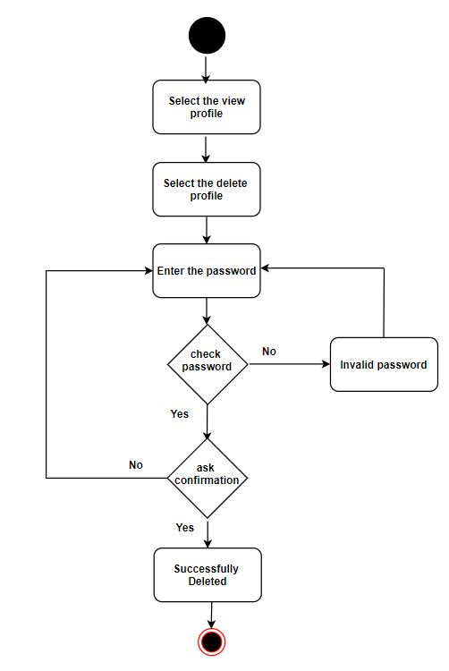

*Figure 51: Vehicle deletes the account*

#### 9.4.5.5 Change availability

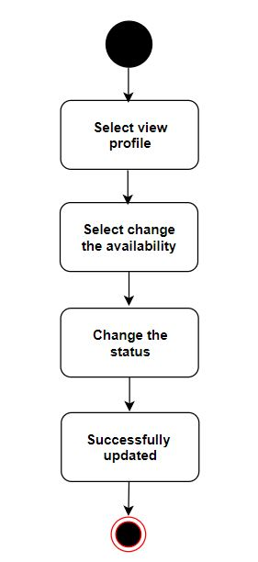

*Figure 52: Vehicle changes availability*

# 10. Non-Functional Requirements

## 10.1 Identification of Quality Attributes

1. Security
2. Performance
3. Usability
4. User-friendliness
5. Portability
6. Maintainability

## 10.2 Suggestion to achieve Quality Attributes

1. Security
   * Required passwords should be longer than 12 characters.
   * Password recovery option
   * Password will save on the database in an encrypted manner.
   * The forms are validated with the required fields.
   * Data backup option (In phpMyAdmin database has an option to export data from the database.)
2. Performance
   * We can improve the performance of the website by speeding the process, decrease the response time, etc.
   * We use PHP programming language for back-end development. So because of that applications can be easily loaded over the slow internet and data speed.
   * We can use minify and combine files to reduce the size of each file as well as the total number of files. From that system's performance will be improved.
   * We can use session variables to pass data.
3. Usability

* We are planning to give our website to chosen users to check whether it is usable or not.
* From this testing, we can identify what the user thinks about our website.

1. User-friendliness

* The proposed website can be accessed easily.
* Users will find travel packages very easily. Because all the packages are divided into categories and subcategories.
* Considering the clean and clear user interfaces, it will help the user to access and affect the website.
* As mentioned before, we are planning to have user testing. So we can get an idea about how they feel about the user-friendliness of our website.

1. Portability

* We are planning to implement our website responsively. So it will compatible with operating systems and also the mobiles.
* So the can use any device to see a good output.

1. Maintainability
   * We will use readable codes which can easily understand.
   * We will use comments to identify the source codes. So code can easily change.
   * We will use automated codes. That will make the code easy to compile.
   * We will use automated validation parts.

# 11. Technologies to be used.

1. Programming languages

* Front-end programming languages
* HTML
* CSS
* JavaScript
* Back-end programming languages

1. PHP

* Database

1. MySQL
2. PHP software requirements

* WAMP server [Microsoft Windows o/s, Apache MySQL PHP]

1. MySQL administrator tool

* phpMyAdmin

1. Diagram drawing tools

* drow.io

1. Documentation tool

* Microsoft Word
* Microsoft Excel

1. Project management software

* Microsoft Project (To create Gantt chart and timeline)

1. Text editing tools

* Visual Studio Code
* Notepad++

1. Contribution platform

* GitHub

# 12. Work Breakdown Structure

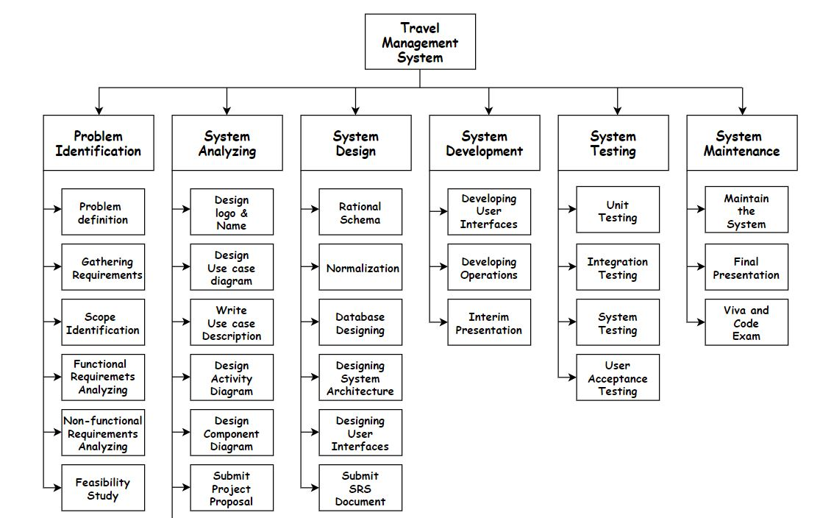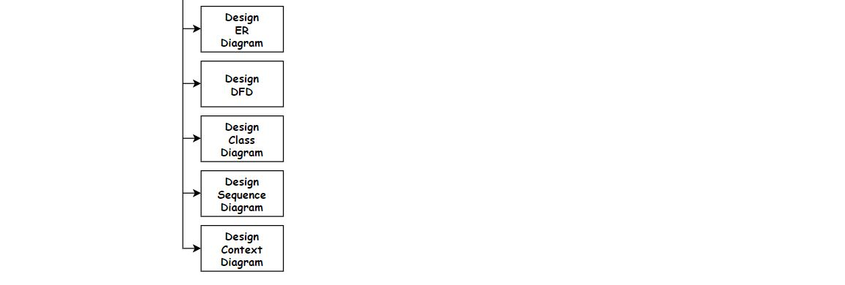

*Figure 53: Work Breakdown Structure*

# 13. Project Timeline

## 13.1 Block Timeline

*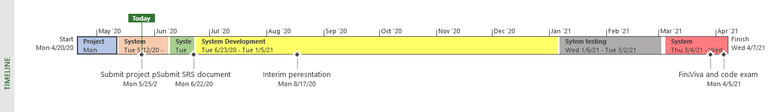Figure 54: Block Timeline-1*

*Figure 55: Block Timeline-2*

## 13.2 Project Milestone Timeline

*Figure 56: Project Milestone Timeline*

# 14. Gantt Chart

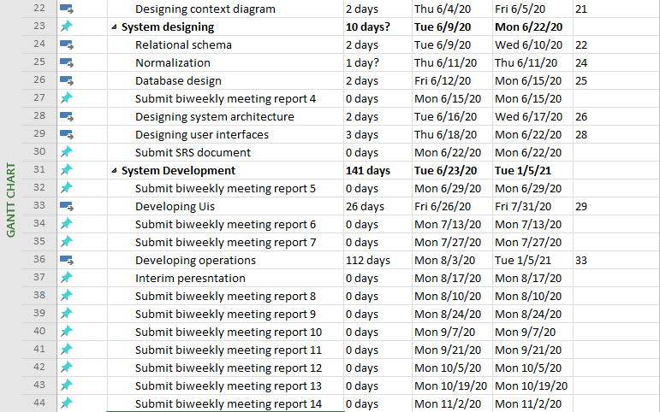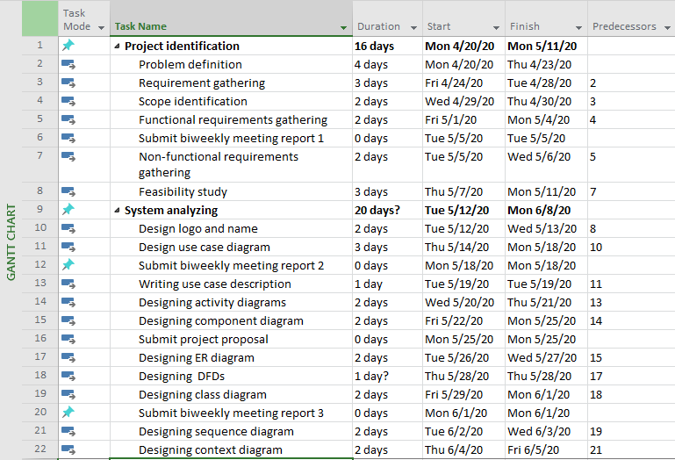

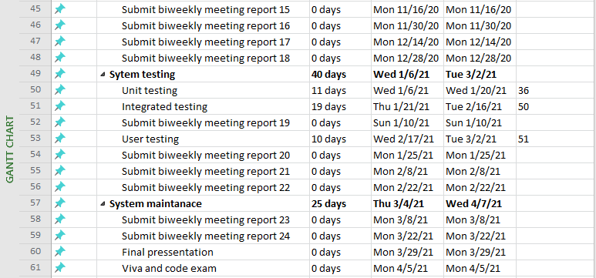

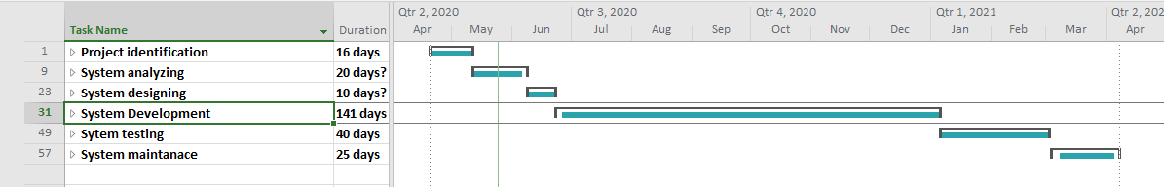

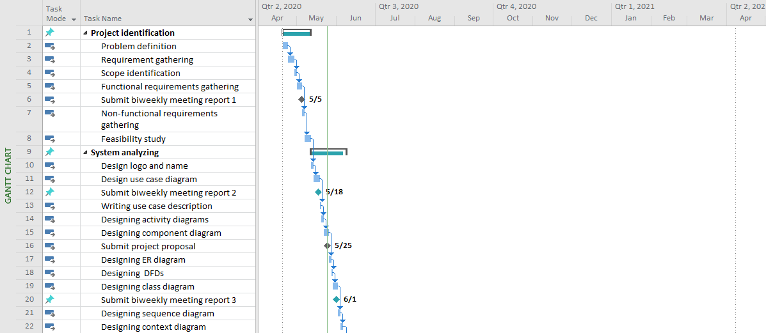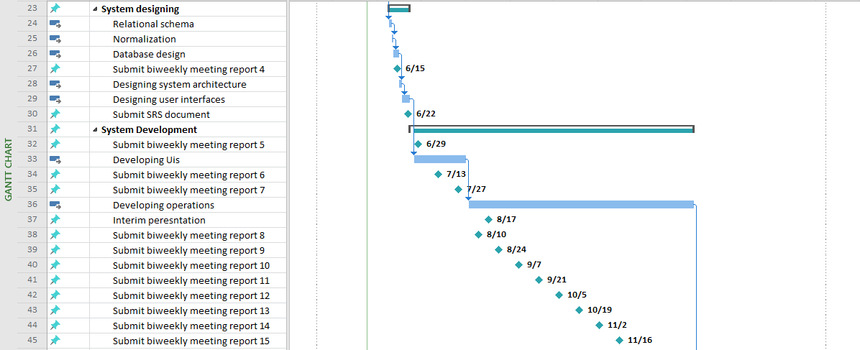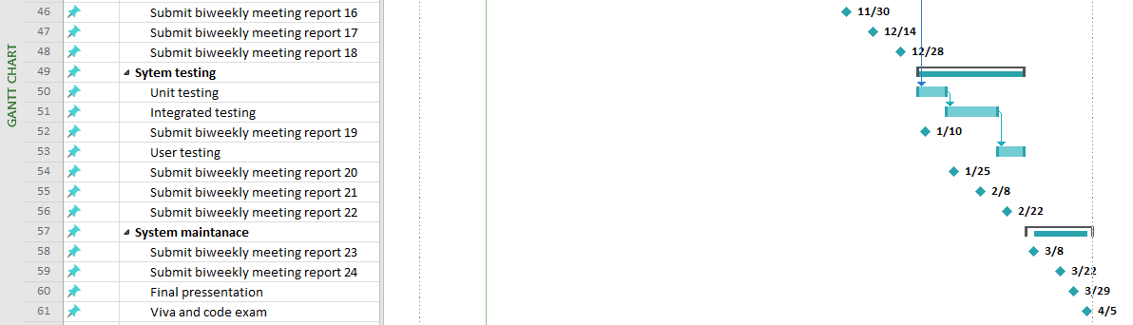

*Figure 57: Gantt chart*

# 15. Declaration

We as members of the project titled Travel Management System, Certify that we will carry out this project according to the guidelines provided by the coordinators and supervisors of the course as well as we will not incorporate, without acknowledgement, any material previously submitted for a degree or diploma in any university. To the best of our knowledge and brief, the project work will not contain any material previously published or written by another person or ourselves except where due reference is made in the text of appropriate places.

|  |  |  |
| --- | --- | --- |
| Index Number | Name of the Student | Signature |
| Asini Pathmila Silva | 18020798 |  |
| Ruwanthi Hemachandra | 18020291 |  |
| Hansaka Sandaruwan | 18020704 |  |
| Sachini Maleesha | 18020356 |  |

# 16. References

1. iamglyka. 2020. *Schedule Feasibility*. [online] Available at: <https://iamglyka.wordpress.com/2013/02/06/schedule-feasibility/> [Accessed 4 May 2020].
2. Web.cse.ohio-state.edu. 2020. *Requirements Document Example*. [online] Available at: <http://web.cse.ohio-state.edu/~bair.41/616/Project/Example_Document/Req_Doc_Example.html> [Accessed 4 May 2020].
3. Programsformca.com. 2020. *UML Diagrams For Tour Management*. [online] Available at: <http://www.programsformca.com/2012/03/uml-diagrams-for-tour-management.html> [Accessed 4 May 2020].
4. Apps, B., 2020. *Technology Stack For Web Application Development*. [online] Rubygarage.org. Available at: <https://rubygarage.org/blog/technology-stack-for-web-development> [Accessed 4 May 2020].
5. Michael Bierman's Randomness. 2020. *Project Feasibility: Should We Include Ethical Feasibility?*. [online] Available at: <https://michaelbierman.wordpress.com/2010/09/15/project-feasibility-should-we-include-ethical-feasibility/> [Accessed 4 May 2020].
6. Simplilearn.com. 2020. *What Is Feasibility Study And Its Importance In Project Management*. [online] Available at: <https://www.simplilearn.com/feasibility-study-article> [Accessed 4 May 2020].
7. Usmani, F., 2020. *Assumptions And Constraints In Project Management | PM Study Circle*. [online] PM Study Circle. Available at: <https://pmstudycircle.com/2012/10/assumptions-and-constraints-in-project-management/> [Accessed 8 May 2020].
8. Masterofproject.com. 2020. *Master | Project Constraints Definition | 7 Common Project Constraints*. [online] Available at: <https://masterofproject.com/blog/7390/project-constraints-definition-7-common-project-constraints> [Accessed 8 May 2020].